**DISEASE DATABASE MANAGEMENT**

**Business Problem Definition**

Healthcare organizations, such as hospitals, clinics, and healthcare providers, need to efficiently manage patient information, track diseases, treatments, and monitor healthcare outcomes. They require a comprehensive database system to store, retrieve, and analyze data related to patients, diseases, medications, and medical treatments. This system should facilitate effective patient management, disease tracking, treatment effectiveness evaluation, and healthcare provider coordination.

**Key Requirements:**

Patient Management: The system should allow healthcare providers to record and manage patient demographics, including personal details, medical history, and insurance information.

Disease Tracking: It should enable tracking of various diseases, including their names, types, severity levels, and potential causes.

Treatment Records: The system needs to maintain records of medical treatments, including medications prescribed, indications for treatments, and their effectiveness percentages.

Healthcare Provider Coordination: Healthcare providers need to be able to coordinate patient care effectively, requiring access to patient information, disease history, and treatment records.

**Database Objectives:**

Data Integrity: Ensure the accuracy and consistency of patient, disease, and treatment data by enforcing referential integrity constraints and foreign key relationships.

Data Accessibility: Enable healthcare providers to access and retrieve patient information quickly and efficiently through well-structured database tables and optimized SQL queries.

Data Analysis: Provide tools and capabilities for analyzing disease trends, treatment effectiveness, and healthcare outcomes to support data-driven decision-making in healthcare management.

**Expected Outcomes:**

Improved Patient Care: By having access to comprehensive patient records, healthcare providers can deliver more personalized and effective care to patients.

Enhanced Disease Management: The ability to track diseases and analyze disease patterns enables healthcare organizations to implement preventive measures and respond effectively to disease outbreaks.

Efficient Healthcare Operations: With streamlined access to patient information and treatment records, healthcare providers can optimize their operations, leading to better resource allocation and cost management.

**Use Cases and Applications**

Public Health Monitoring: The database can be used by healthcare providers and public health officials to monitor and manage disease outbreaks, understanding patterns in disease spread, and the effectiveness of treatments.

Patient Care: Hospitals and clinics can use this database to manage patient records, track treatment plans, and ensure that patients are receiving appropriate care based on their demographics and geographic location.

Research and Development: Researchers can use data from this database to study the effectiveness of different medicines on various diseases, analyze the impact of genetics (race) and environment (location) on health, and develop more effective treatments.

Insurance Processing: The database helps insurance companies to process claims more efficiently by having access to detailed patient records and their treatment history.

**Disease ER Diagram**

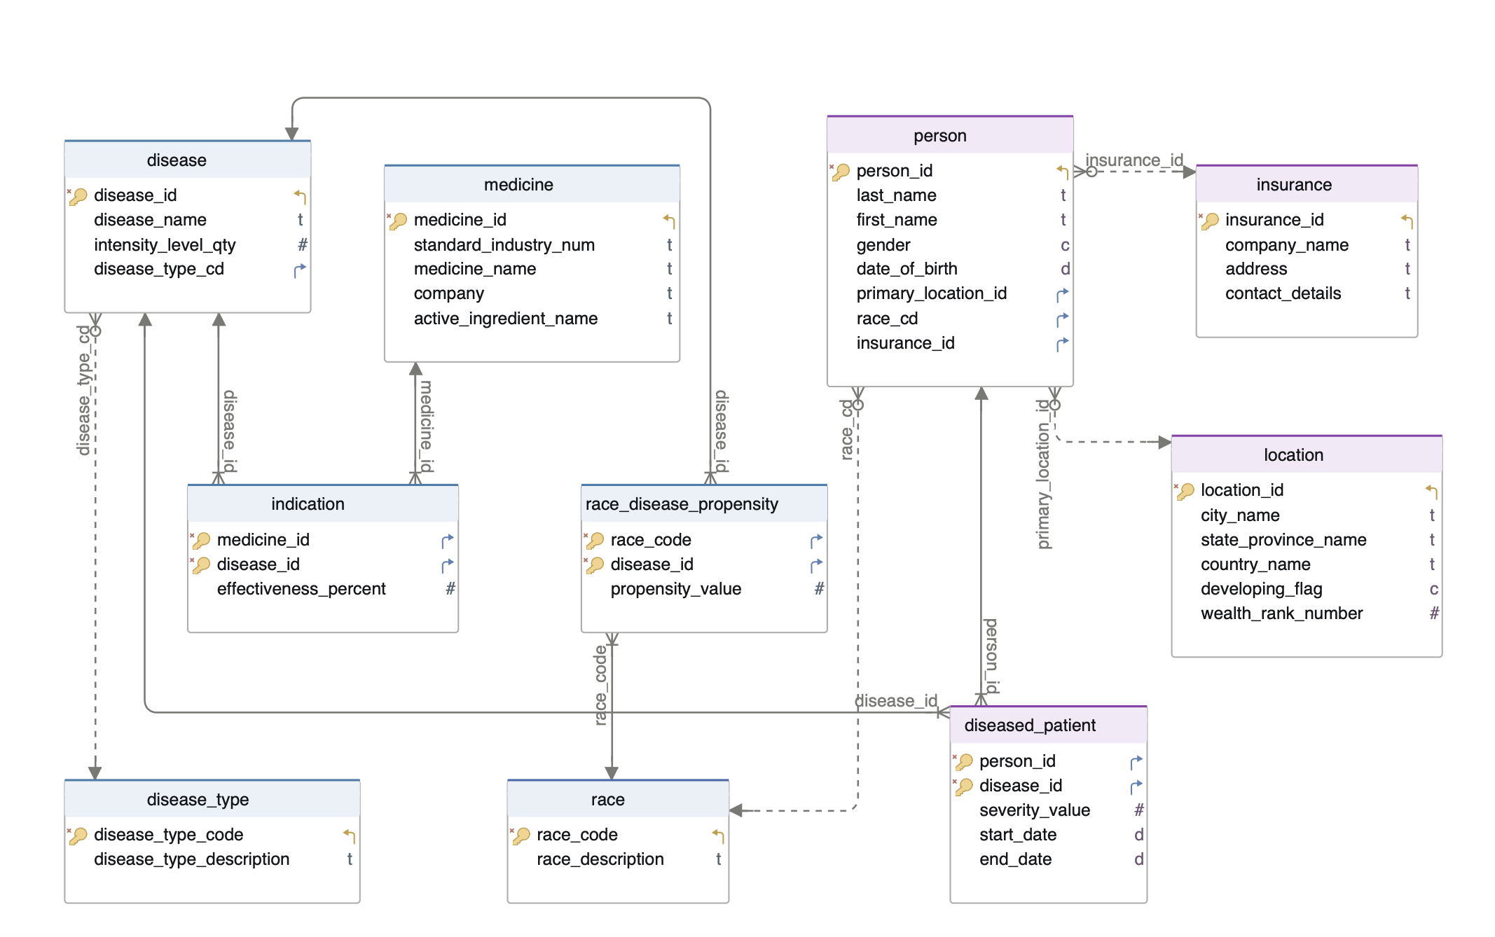

**DML & DDL Queries:**

-- Create statement to create(DDL statment) disease\_type table

CREATE TABLE public.Disease\_Type

(

Disease\_Type\_Code char(5) PRIMARY KEY,

Disease\_Type\_Description Varchar(500)

);

-- Create table syntax for disease table

CREATE TABLE public.Disease

(

Disease\_ID INT generated always as identity primary key,

Disease\_name Varchar(100),

Intensity\_Level\_Qty INT,

Disease\_Type\_CD char(5),

CONSTRAINT Fkey\_Disease\_Type\_CD FOREIGN KEY (Disease\_Type\_CD)

REFERENCES public.Disease\_Type (Disease\_Type\_Code)

);

-- Renaming column name using alter statement

-- alter table public.disease rename column intensity\_levely\_qty to intensity\_level\_qty

-- Creating location table

CREATE TABLE Location

(

Location\_ID INT generated always as identity primary key,

City\_Name VARCHAR(100),

State\_Province\_Name VARCHAR(100),

Country\_Name Varchar(100),

Developing\_Flag char(1),

Wealth\_Rank\_Number INT

);

-- Create race table

CREATE TABLE public.Race

(

Race\_Code char(5) PRIMARY KEY,

Race\_Description VARCHAR(500)

);

--create insurance table

CREATE TABLE public.insurance

(

insurance\_id integer NOT NULL GENERATED ALWAYS AS IDENTITY ,

company\_name character varying(150) ,

address character varying(150) ,

contact\_details character varying(15),

CONSTRAINT insurance\_pkey PRIMARY KEY (insurance\_id)

)

--Create person table

CREATE TABLE IF NOT EXISTS public.person

(

person\_id integer NOT NULL GENERATED ALWAYS AS IDENTITY ,

last\_name character varying(50) ,

first\_name character varying(100),

gender character(1),

date\_of\_birth date,

primary\_location\_id integer,

race\_cd character(5),

insurance\_id integer,

CONSTRAINT person\_pkey PRIMARY KEY (person\_id),

CONSTRAINT fkey\_primary\_location\_id FOREIGN KEY (primary\_location\_id)

REFERENCES public.location (location\_id)

ON UPDATE NO ACTION

ON DELETE NO ACTION,

CONSTRAINT fkey\_race\_cd FOREIGN KEY (race\_cd)

REFERENCES public.race (race\_code)

ON UPDATE NO ACTION

ON DELETE NO ACTION,

CONSTRAINT insurance\_id\_fkey FOREIGN KEY (insurance\_id)

REFERENCES public.insurance (insurance\_id)

ON UPDATE NO ACTION

ON DELETE NO ACTION

)

-- Alter table statement to add and drop constraint

alter table person add constraint insurance\_id\_fkey foreign key (insurance\_id)

REFERENCES public.insurance(insurance\_id);

alter table person drop constraint insurance\_id\_fkey foreign key (insurance\_id)

REFERENCES public.insurance(insurance\_id);

-- Create diseased Patient table

CREATE TABLE public.Diseased\_Patient

(

Person\_ID INT,

Disease\_ID INT,

Severity\_Value INT,

Start\_Date date,

End\_Date date,

CONSTRAINT Pkey\_Diseased\_patient PRIMARY KEY (Person\_ID, Disease\_ID),

CONSTRAINT Fkey\_Person\_ID FOREIGN KEY (Person\_ID)

REFERENCES public.Person (Person\_ID),

CONSTRAINT Fkey\_Disease\_ID FOREIGN KEY (Disease\_ID)

REFERENCES public.Disease (Disease\_ID)

);

--Create Race Disease Propensity Table

CREATE TABLE public.Race\_Disease\_Propensity

(

Race\_Code char(5),

Disease\_ID int,

Propensity\_Value int,

CONSTRAINT Pkey\_Race\_Disease\_Propensity PRIMARY KEY (Race\_Code,Disease\_ID),

CONSTRAINT Fkey\_Race\_Code FOREIGN KEY (Race\_Code)

REFERENCES public.Race(Race\_Code),

CONSTRAINT Fkey\_Disease\_ID FOREIGN KEY (Disease\_ID)

REFERENCES public.Disease (Disease\_ID)

);

--Create Medicine table

CREATE TABLE public.Medicine

(

Medicine\_ID INT generated always as identity primary key,

Standard\_Industry\_Num Varchar(30),

Medicine\_Name Varchar(200),

Company Varchar(150),

Active\_Ingredient\_Name Varchar(200)

);

-- Create Indications table

CREATE TABLE public.indication

(

Medicine\_ID INT ,

Disease\_ID INT,

Indication\_Date DATE,

Effectiveness\_Percent float,

CONSTRAINT Pkey\_Indication PRIMARY KEY (Medicine\_ID, Disease\_ID),

CONSTRAINT Fkey\_Medicine\_ID FOREIGN KEY (Medicine\_ID)

REFERENCES public.Medicine (Medicine\_ID),

CONSTRAINT Fkey\_Indication\_Disease\_ID FOREIGN KEY (Disease\_ID)

REFERENCES public.Disease(Disease\_ID)

);

-- Insert data into Disease\_Type Table

INSERT INTO disease\_type(disease\_type\_code, disease\_type\_description) VALUES

('DCNCR', 'Cancer is a disease characterized by uncontrollable growth and spreading of body cells.'),

('DCNPX', 'Chickenpox is caused by the varicella-zoster virus, resulting in an itchy rash with fluid-filled blisters.'),

('DCNCD', 'The common cold is a viral infection affecting the nose and throat, often resulting in mild symptoms.'),

('DAIDS', 'Acquired immunodeficiency syndrome (AIDS) is a chronic condition caused by HIV, leading to weakened immunity.'),

('DIFZA', 'Flu (influenza) is a respiratory infection causing symptoms such as fever and cough.'),

('DMLRA', 'Malaria is a potentially fatal disease transmitted by mosquitoes, causing high fevers and flu-like symptoms.'),

('DPLIO', 'Poliomyelitis (polio) is a viral infection affecting the central nervous system, leading to paralysis.'),

('DPMNA', 'Pneumonia is a lung infection causing inflammation and respiratory symptoms.'),

('DTRCS', 'Tuberculosis (TB) is a bacterial infection primarily affecting the lungs, but can spread to other organs.'),

('DCAD', 'Coronary artery disease restricts blood flow to the heart due to cholesterol deposits in arteries.'),

('DDSMS', 'Diabetes mellitus affects blood sugar levels, leading to various complications in the body.'),

('DSELM', 'Lyme disease is transmitted by ticks, causing symptoms such as fever and skin rash.'),

('DMELS', 'Measles is a highly contagious viral illness characterized by fever and rash.'),

('DMEGS', 'Meningitis is an inflammation of the membranes surrounding the brain and spinal cord.'),

('DMUPS', 'Mumps is a viral infection causing swelling of the salivary glands.'),

('DRBLA', 'Rubella is a viral infection causing a mild illness with symptoms such as rash and fever.'),

('DSMAS', 'Salmonella infections result from contaminated food or water, leading to gastrointestinal symptoms.'),

('DSHGS', 'Shingles is a viral infection causing a painful rash along nerve pathways.'),

('DTETU', 'Tetanus is a bacterial infection causing muscle stiffness and spasms.'),

('DVIHE', 'Viral hepatitis is a liver infection caused by various hepatitis viruses, leading to liver inflammation.');

-- Insert Data into Disease Table

INSERT INTO disease (disease\_name, intensity\_level\_qty, disease\_type\_cd) VALUES

('Cancer', 10, 'DCNCR'),

('Chickenpox', 4, 'DCNPX'),

('The common cold', 1, 'DCNCD'),

('Acquired immunodeficiency syndrome (AIDS)', 10, 'DAIDS'),

('Flu (influenza)', 5, 'DIFZA'),

('Malaria', 6, 'DMLRA'),

('Coronary artery disease', 10, 'DCAD'),

('Poliomyelitis (polio)', 5, 'DPLIO'),

('Pneumonia', 7, 'DPMNA'),

('Tuberculosis (TB)', 6, 'DTRCS'),

('Diabetes mellitus', 8, 'DDSMS'),

('Lyme disease', 4, 'DSELM'),

('Measles', 8, 'DMELS'),

('Meningitis', 7, 'DMEGS'),

('Mumps', 6, 'DMUPS'),

('Rubella', 8, 'DRBLA'),

('Salmonella infections', 4, 'DSMAS'),

('Shingles', 4, 'DSHGS'),

('Tetanus', 7, 'DTETU'),

('Viral hepatitis', 8, 'DVIHE');

-- Inserting Data Into Location Table

INSERT INTO Location (City\_Name, State\_Province\_Name, Country\_Name, Developing\_Flag, Wealth\_Rank\_Number) VALUES

('New Jersey', 'New York', 'United States', 'Y', 1),

('Teltow', 'Berlin', 'Germany', 'Y', 2),

('Bordeaux', 'Paris', 'France', 'Y', 4),

('Kawasaki', 'Tokyo', 'Japan', 'Y', 3),

('Witham', 'Essex', 'England', 'Y', 5),

('Capranica', 'Rome', 'Italy', 'Y', 6),

('Ontario', 'Toronto', 'Canada', 'Y', 7),

('Jaipur', 'Rajasthan', 'India', 'Y', 8),

('Dublin', 'Leinstar', 'Ireland', 'Y', 9),

('Abuja', 'Nigeria', 'Africa', 'Y', 10);

-- Inserting data into race table

INSERT INTO race (Race\_Code, Race\_Description) VALUES

('ASIAN', 'Asian – Originating from the Far East, Southeast Asia, or the Indian subcontinent.'),

('BLACK', 'Black or African American – Originating from any of the Black racial groups of Africa.'),

('LATIN', 'Hispanic or Latino – Of Cuban, Mexican, Puerto Rican, South or Central American origin, regardless of race.'),

('WHITE', 'White – Identifying with nationalities or ethnic groups from Europe, the Middle East, or North Africa.'),

('ARAB', 'Arab – A member of Semitic people from the Middle East and North Africa.'),

('WTHPC', 'White Hispanic or Latino – Hispanic or Latino descent, primarily of white Mexican Americans.'),

('WSTHC', 'West Indies – Ethnically diverse population from Spanish, French, British, or Dutch colonists.'),

('AMNID', 'American Indian or Alaska Native – Native peoples of North and South America with tribal affiliation.'),

('PACIF', 'Pacific Islander – Indigenous peoples of the Pacific Islands, including Hawaii and New Zealand.');

-- Inserting data into person table

INSERT INTO PERSON (Last\_Name, First\_Name, Gender, Date\_Of\_Birth, Primary\_Location\_ID, Race\_CD) VALUES

('Cheng', 'Daniella', 'F', '1989-09-29', 1, 'ASIAN'),

('Chen', 'Harshavardhan Sai', 'M', '1992-01-07', 1, 'ASIAN'),

('Choi', 'Manasi', 'F', '1999-01-07', 1, 'ASIAN'),

('Clarke', 'Daniel', 'M', '1999-12-01', 2, 'WTHPC'),

('Clement', 'Sadiqua', 'M', '1979-07-30', 2, 'WTHPC'),

('Clyne', 'Dizhanae', 'F', '1999-03-11', 2, 'WTHPC'),

('Cohen', 'Wendy', 'F', '1996-01-07', 3, 'WSTHC'),

('Colton', 'Jessica', 'F', '1999-03-17', 3, 'WSTHC'),

('Creehan', 'Nicole', 'M', '1998-04-01', 3, 'WSTHC'),

('Cuch', 'Brittany', 'F', '1975-05-01', 4, 'WHITE'),

('Cuesta', 'Doris', 'M', '1999-05-01', 4, 'WHITE'),

('Cummins', 'Lauren', 'M', '1998-10-01', 4, 'WHITE'),

('Daly', 'Kaitlin', 'F', '1978-05-18', 5, 'AMNID'),

('Datuin', 'Leah', 'F', '1999-05-19', 5, 'AMNID'),

('Davis', 'Adva', 'F', '1972-05-20', 5, 'AMNID'),

('De La Cruz', 'Arianna', 'F', '1967-09-29', 6, 'ARAB'),

('De La Rosa', 'ROCIO', 'M', '1998-05-07', 6, 'ARAB'),

('De Leon Serrano', 'Diana', 'M', '1997-12-23', 6, 'ARAB'),

('Deng', 'Jeeho', 'M', '1977-12-11', 7, 'LATIN'),

('Depietri', 'Elham', 'F', '1963-05-14', 7, 'LATIN'),

('Deutsch', 'Min', 'M', '1968-04-21', 7, 'LATIN'),

('Imhoff', 'Mengyao', 'M', '1998-08-26', 8, 'BLACK'),

('Halpert', 'Kairong', 'M', '1997-07-24', 8, 'BLACK'),

('Halikias', 'Jinming', 'F', '1995-05-24', 8, 'BLACK');

-- Inserting records into diseased\_patient table

INSERT INTO diseased\_patient (Person\_ID, Disease\_ID, Severity\_Value, Start\_Date, End\_Date)

VALUES

(1, 1, 3, '2015-08-15', '2015-06-15'),

(2, 2, 1, '1994-08-15', '1997-08-20'),

(3, 2, 4, '2000-05-01', '2000-05-01'),

(4, 1, 10, '2015-08-15', '2018-06-15'),

(5, 7, 3, '2002-09-10', '2002-09-15'),

(6, 4, 10, '2010-01-01', '2011-02-10'),

(7, 9, 7, '2012-11-14', '2014-06-15'),

(8, 10, 6, '2008-05-10', '2008-09-15'),

(9, 11, 3, '2019-08-15','2019-08-16'),

(10, 1, 10, '2019-02-07', '2020-01-08'),

(11, 3, 5, '2007-08-10', '2007-09-15'),

(12, 6, 3, '2004-10-15', '2004-12-15'),

(13, 1, 3, '2019-08-02', '2022-06-15'),

(14, 1, 4, '2002-06-15', '2002-06-21'),

(15, 2, 5, '2022-04-19', '2022-04-29'),

(1, 10, 8, '2017-08-15', '2018-06-15'),

(2, 1, 3, '1980-08-15', '1985-06-15'),

(2, 3, 3, '2009-05-10', '2009-06-09'),

(3, 10, 8, '2018-01-15', '2018-03-15'),

(4, 7, 9, '2002-01-15', '2002-01-31'),

(5, 2, 6, '2008-10-01', '2008-10-15'),

(16, 11, 6, '2015-08-15','2019-08-16'),

(17, 8, 6, '2000-08-15', '2019-08-16'),

(18, 10, 5, '2001-06-22', '2001-08-15'),

(19, 7, 7, '2017-09-09', '2017-10-25'),

(20, 6, 3, '2014-03-10', '2014-06-15'),

(21, 8, 4, '2007-08-12','2019-08-16');

-- Update statement to update a single row

UPDATE diseased\_patient

SET start\_date = '2015-06-14'

WHERE end\_date = '2015-06-15';

-- Inserting data into Insurance table

INSERT INTO insurance (company\_name, address, contact\_details)

VALUES

('Blue Cross Blue Shield Association', '225 North Michigan Ave. Chicago, IL 60601', '8554809172'),

('Symetra', '8508 Plum Creek Dr. Alabama, AC 52689', '3846228768'),

('21st Century Insurance', '9117 Goshen Valley Dr. Alaska, CS 45963', '3815450810'),

('Acuity Insurance', '22713 Robin Ct. Arizona, GU 45896', '3676834865'),

('Aflac', '8505 Churchill Downs Rd. Connecticut, VHUJO 48952', '3671238495'),

('Allianz Life', '22308 Bertie Farm Ct. Georgia, LJ 25689', '3596259824'),

('Bankers Life and Casualty Company', '21804 Churchill Downs Ct. Hawaii, ST 69812', '3423322614'),

('Berkshire Hathaway', '22521 Sweetleaf Ln. Idaho, IH 12598', '3351514273'),

('CareSource', '21628 Goshen Oaks Rd. Indiana, GU 54863', '3325225532'),

('Chubb Corp', '21917 Foxlair Rd. Iowa, EV 26589', '3278483984'),

('Colonial Life Accident Insurance Company', '22710 Woodfield Rd. Kansas, RU 98561', '3187003242'),

('Delta Dental', '22410 Sweetleaf Ln. Kentucky, UI 98512', '2969515920'),

('Esurance', '9208 Huntmaster Rd. Louisiana, XU 69842', '2863446574'),

('Farmers Insurance Group', '21918 Huntmaster Dr. Maine, TI 85327', '2531318505'),

('GAINSCO', '8533 Churchill Downs Rd. Maryland, YA 96584', '2323160705'),

('Gerber Life Insurance Company', '9103 Charlie Farm Ct. Massachusetts, RC 98457', '2070961281'),

('Gracy Title Company', '01ST Tony ST. Michigan, HC 69842', '5895125698'),

('The Guardian Life Insurance Company of America', '06TH HP AVE. Minnesota, BU 98512', '5984809172'),

('GuideOne Insurance', '08TH TI ST. Montana, SI 65891', '8894259172'),

('Hanover Insurance', '09TH Sunny AVE. New Hampshire, IJ 59841', '6054885672'),

('HCC Insurance Holdings', 'SAM JORDANS WAY Ave. Rhode Island, RS 65412', '6854809126'),

('Kentucky Farm Bureau', 'ABBEY ST. Utah, BG 98541', '2954569842'),

('Liberty Mutual', 'TONI STONE XING. South Carolina, UA 85426', '5453698172'),

('Manhattan Life Insurance Company', 'ACACIA ST. South Dakota, TI 87549', '2569809172'),

('Society Insurance', 'SHEPHARD PL. Pennsylvania, TU 89547', '2564589172');

-- Insert data into Medicine table

INSERT INTO medicine (Standard\_Industry\_Num, Medicine\_Name, Company, Active\_ingredient\_Name)

VALUES

(23452, 'Acetaminophen', 'McNeil Consumer Healthcare', 'Powdered Cellulose, Pregelatinized Starch'),

(94488, 'Vitamin D', 'Drisdol', 'CHOLECALCIFEROL, ALPHA.-TOCOPHEROL D'),

(459627, 'Ibuprofen', 'Motrin', 'p - isobutylphenyl, propionic acid'),

(458621, 'Levothyroxine', 'Synthroid', 'synthetic crystalline, tetraiodothyronine sodium salt'),

(895126, 'Lisinopril', 'Prinivil', 'calcium phosphate, mannitol'),

(789514, 'Amlodipine', 'Norvasc', 'calcium phosphate dibasic, microcrystalline cellulose'),

(269865, 'Prednisone', 'Deltasone', 'anhydrous lactose, colloidal silicon dioxide'),

(369547, 'Amphetamine', 'Adderall', 'entactogens,hallucinogens'),

(589416, 'Albuterol sulfate HFA', 'Ventolin HFA', 'ethanol, oleic acid'),

(36214, 'Alprazolam', 'Xanax', 'Cellulose, corn starchh'),

(894126, 'Cyclobenzaprine', 'Flexeril', 'hydroxypropyl cellulose, hydroxypropyl methylcellulose'),

(125879, 'Azithromycin', 'Zithromax Z-Pak', 'dibasic calcium phosphate anhydrous, pregelatinized starch'),

(65489, 'Gabapentin', 'Neurontin', 'corn starch, magnesium stearate'),

(256148, 'Cephalexin', 'Keflex', 'hypromellose, magnesium stearate'),

(256148, 'Cetirizine', 'Zyrtec', 'pregelatinized starch, lactose'),

(256148, 'Hydrochlorothiazide', 'Microzide', 'microcrystalline cellulose, pregelatinized starch'),

(256148, 'Metformin', 'Glucophage', 'pregelatinized starch, magnesium stearate'),

(256148, 'Atorvastatin', 'Lipitor', 'calcium carbonate, USP'),

(256148, 'Amoxicillin', 'Augmentin', 'Colloidal Silicon Dioxide, Magnesium Stearate'),

(256148, 'Vitamin D3', 'D3-50', 'CHOLECALCIFEROL, .ALPHA.-TOCOPHEROL, D-'),

(256148, 'Benzonatate', 'Tessalon Perles', 'D&C Yellow No. 10, gelatin'),

(256148, 'Losartan', 'Cozaar', 'lactose monohydrate, starch pregelatinised'),

(256148, 'Metoprolol succinate ER', 'Toprol XL', 'colloidal silicon dioxide, croscarmellose sodium'),

(256148, 'Trazodone', 'Desyrel', 'Trazodone hydrochloride, USP'),

(256148, 'Clonazepam', 'Klonopin', 'docusate sodium, lactose monohydrate'),

(256148, 'Zolpidem', 'Ambien', 'lactose monohydrate, microcrystalline cellulose'),

(256148, 'Fluconazole', 'Diflucan', 'microcrystalline cellulose, dibasic calcium'),

(256148, 'Metronidazole', 'Flagyl', 'corn starch, magnesium stearate'),

(256148, 'Furosemide', 'Lasix', 'lactose monohydrate NF, magnesium stearate NF'),

(256148, 'Ferosul', 'ferrous sulfate', 'Microcrystalline, Cellulose');

-- Inserting Data into Race\_Disease\_propensity table

INSERT INTO Race\_Disease\_Propensity (Race\_code, Disease\_ID, Propensity\_Value) VALUES

('AMNID', 1, 5),

('AMNID', 2, 6),

('AMNID', 3, 8),

('ARAB', 4, 10),

('ARAB', 2, 8),

('ARAB', 3, 10),

('ASIAN', 10, 5),

('ASIAN', 9, 6),

('ASIAN', 3, 6),

('BLACK', 7, 5),

('BLACK', 10, 1),

('LATIN', 5, 9),

('LATIN', 1, 10),

('LATIN', 2, 9),

('WHITE', 11, 9),

('WHITE', 2, 1),

('WHITE', 9, 9),

('WHITE', 5, 9),

('WSTHC', 2, 10),

('WHITE', 7, 2),

('WHITE', 10, 2),

('WTHPC', 1, 2),

('WTHPC', 2, 3),

('WTHPC', 11, 10);

-- Inserting data into Indication Table

INSERT INTO Indication (Medicine\_ID, Disease\_ID, Indication\_Date, Effectiveness\_Percent) VALUES

(1, 1, '2002-07-01', 100),

(1, 2, '2012-09-29', 51.05),

(1, 5, '2019-09-29', 60),

(2, 9, '1999-09-20', 61),

(2, 11, '2002-08-29', 10),

(3, 4, '1999-10-21', 72.09),

(3, 11, '1996-09-29', 50.08),

(4, 7, '1992-03-21', 68),

(7, 7, '2006-09-29', 82),

(5, 9, '2008-09-29', 60),

(6, 11, '2010-07-29', 89),

(6, 10, '2014-10-29', 98),

(9, 8, '2010-09-29', 100),

(19, 6, '2000-06-22', 59),

(20, 9, '2018-09-29', 96),

(17, 11, '2015-07-20', 83.40),

(18, 1, '2012-09-29', 79),

(19, 4, '2012-11-27', 83),

(20, 5, '2024-12-29', 92.20),

(21, 11, '2031-10-26', 57.90),

(22, 9, '2024-09-29', 90.8),

(23, 1, '2035-02-28', 97.80),

(24, 7, '2028-05-24', 32.09),

(25, 7, '2022-09-29', 89.82),

(26, 9, '2027-08-29', 78.89),

(27, 10, '2031-12-29', 90.42),

(28, 11, '2036-09-29', 95.00);

-- Selecting all data from public schema

SELECT \* FROM disease;

SELECT \* FROM disease\_type;

SELECT \* FROM diseased\_patient;

SELECT \* FROM indication;

SELECT \* FROM insurance;

SELECT \* FROM location;

SELECT \* FROM medicine;

SELECT \* FROM race;

SELECT \* FROM race\_disease\_propensity;

-- **Operational Queries**

-- Interesting analyses that can be generated from Disease model (OLTP Database Public Schema)

/\* 1. Analyzing trends in disease prevalence:

This query returns the number of cases and the average severity of each disease \*/

SELECT disease.disease\_name, COUNT(diseased\_patient.person\_id) AS number\_of\_cases,

ROUND(AVG(diseased\_patient.severity\_value), 2) AS average\_severity

FROM diseased\_patient

INNER JOIN disease ON diseased\_patient.disease\_id = disease.disease\_id

GROUP BY disease.disease\_name;

/\* 2. Examining the relationship between race and disease propensity:

This query returns the average propensity value for each race and disease combination. \*/

SELECT race.race\_code, disease.disease\_name, ROUND(AVG(race\_disease\_propensity.propensity\_value), 2)

AS average\_propensity

FROM race\_disease\_propensity

INNER JOIN race ON race\_disease\_propensity.race\_code = race.race\_code

INNER JOIN disease ON race\_disease\_propensity.disease\_id = disease.disease\_id

GROUP BY race.race\_code, disease.disease\_name;

/\* 3. Identifying the most effective treatments:

This query returns the medicine with the highest effectiveness percent for each disease. \*/

SELECT disease.disease\_name, medicine.medicine\_name, MAX(indication.effectiveness\_percent) AS maximum\_effectiveness

FROM indication

INNER JOIN disease ON indication.disease\_id = disease.disease\_id

INNER JOIN medicine ON indication.medicine\_id = medicine.medicine\_id

GROUP BY disease.disease\_name, medicine.medicine\_name;

/\* 4. Analyzing the distribution of diseases by location:

This query returns the number of cases for each location. \*/

SELECT location.city\_name, location.state\_province\_name, location.country\_name,

COUNT(diseased\_patient.person\_id) AS number\_of\_cases

FROM diseased\_patient

INNER JOIN person ON diseased\_patient.person\_id = person.person\_id

INNER JOIN location ON person.primary\_location\_id = location.location\_id

GROUP BY location.city\_name, location.state\_province\_name, location.country\_name;

/\* 5. Query that analyzes the relationship between gender and the prevalence of different diseases in different countries:

This query returns the number of cases for each disease, country, and gender combination. \*/

SELECT disease.disease\_name, location.country\_name, person.gender,

COUNT(diseased\_patient.person\_id) AS number\_of\_cases

FROM diseased\_patient

INNER JOIN disease ON diseased\_patient.disease\_id = disease.disease\_id

INNER JOIN person ON diseased\_patient.person\_id = person.person\_id

INNER JOIN location ON person.primary\_location\_id = location.location\_id

GROUP BY disease.disease\_name, location.country\_name, person.gender;

/\* 6. Patient and Medicine Information.

This query returns data about each patient's personal information, location, disease, and the medicine used to treat the disease. \*/

SELECT p.person\_id, CONCAT(p.last\_name, ' ', p.first\_name) AS "Patient Name", p.gender, l.country\_name,

dp.disease\_id, d.disease\_name, i.medicine\_id, m.medicine\_name, i.effectiveness\_percent

FROM location l INNER JOIN person p ON l.location\_id=p.primary\_location\_id INNER JOIN

diseased\_patient dp ON p.person\_id = dp.person\_id INNER JOIN disease d ON

dp.disease\_id = d.disease\_id INNER JOIN indication i ON d.disease\_id = i.disease\_id

INNER JOIN medicine m ON m.medicine\_id = i.medicine\_id

ORDER BY 1;

/\* 7. Maximum Medicine Effectiveness for Each Disease

It returns the name of each disease and the name of the medicine with the highest effectiveness percentagenfor that disease. The results are grouped by disease name and sorted by disease name and medicine name. \*/

SELECT d.disease\_name, m.medicine\_name, MAX(i.effectiveness\_percent)

FROM disease d INNER JOIN indication i ON i.disease\_id = d.disease\_id

INNER JOIN medicine m ON i.medicine\_id = m.medicine\_id

GROUP BY d.disease\_name, m.medicine\_name

ORDER BY 1, 2, 3;

/\* 8. Patient Disease Count by Race

The query returns the data sorted by the count of disease IDs in descending order.

The results are grouped by patient name and race code, and the count of diseases for each group is returned. \*/

SELECT CONCAT(p.last\_name, ' ', p.first\_name) AS "Patient Name", COUNT(dp.disease\_id), r.race\_code

FROM person p INNER JOIN diseased\_patient dp ON p.person\_id = dp.person\_id

INNER JOIN race r ON p.race\_cd = r.race\_code GROUP BY p.last\_name, p.first\_name, r.race\_code

ORDER BY 2 DESC;

/\* 9. Patient Diagnosis and Medicine Information.

The query returns the data sorted in the order it was retrieved. It returns information about each patient's

diagnosis, including the patient's name, age at diagnosis, disease, and the medicine used to treat the

disease. \*/

SELECT p.first\_name, p.last\_name, p.date\_of\_birth,

EXTRACT(YEAR FROM dp.start\_date) - EXTRACT(YEAR FROM p.date\_of\_birth) AS age\_at\_diagnosis,

d.disease\_name, m.medicine\_name, m.company

FROM diseased\_patient dp

JOIN person p ON dp.person\_id = p.person\_id

JOIN indication i ON dp.disease\_id = i.disease\_id

JOIN disease d ON i.disease\_id = d.disease\_id

JOIN medicine m ON i.medicine\_id = m.medicine\_id;

/\* 10. Procedure that will return the medicine name and its effectiveness.

It takes disease name as input and returns medicine name and its effectiveness. \*/

CREATE OR REPLACE FUNCTION get\_best\_medicine\_for\_disease\_by\_name(disease\_name VARCHAR(100))

RETURNS TABLE (medicine\_name VARCHAR(200), effectiveness\_percent FLOAT) AS $$

BEGIN

RETURN QUERY

SELECT m.medicine\_name, i.effectiveness\_percent

FROM indication i

JOIN medicine m ON i.medicine\_id = m.medicine\_id

JOIN disease d ON i.disease\_id = d.disease\_id

WHERE d.disease\_name = $1

ORDER BY i.effectiveness\_percent DESC

LIMIT 1;

END $$

LANGUAGE plpgsql;

-- Use the following statement to fetch the result or call the procedure

SELECT \* FROM get\_best\_medicine\_for\_disease\_by\_name('Malaria');

**Operational Queries:**

1. Analyzing trends in disease prevalence:

This query returns the number of cases and the average severity of each disease.

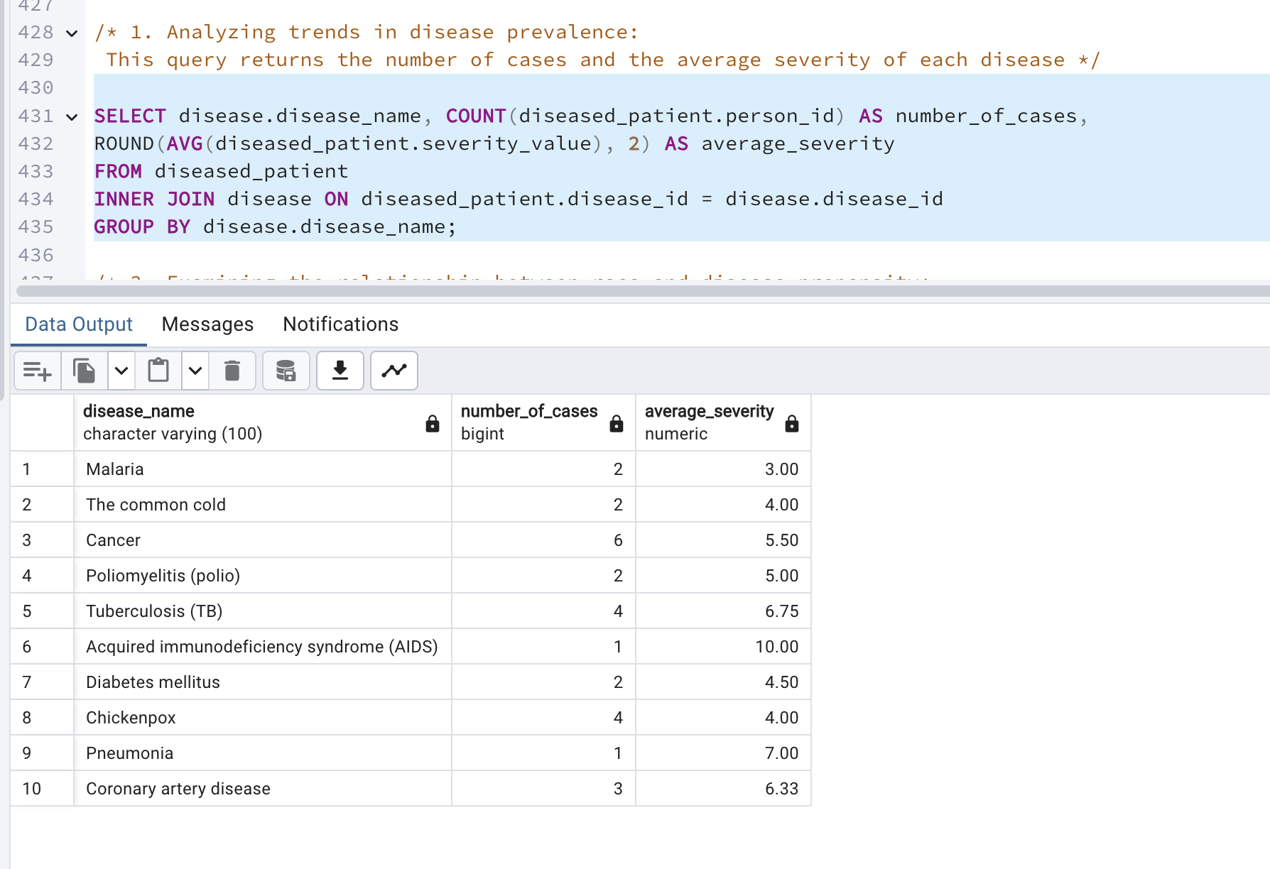

2. Examining the relationship between race and disease propensity:

This query returns the average propensity value for each race and disease combination.

**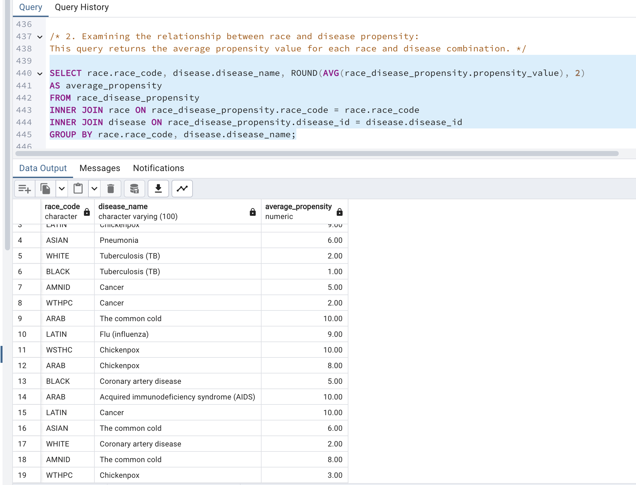**

3. Identifying the most effective treatments:

This query returns the medicine with the highest effectiveness percent for each disease.

**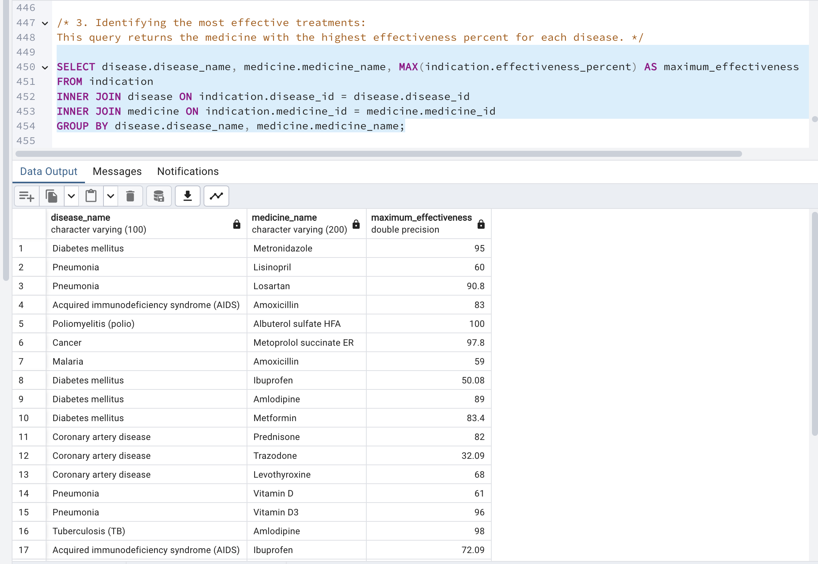**

4. Analyzing the distribution of diseases by location:

This query returns the number of cases for each location.

**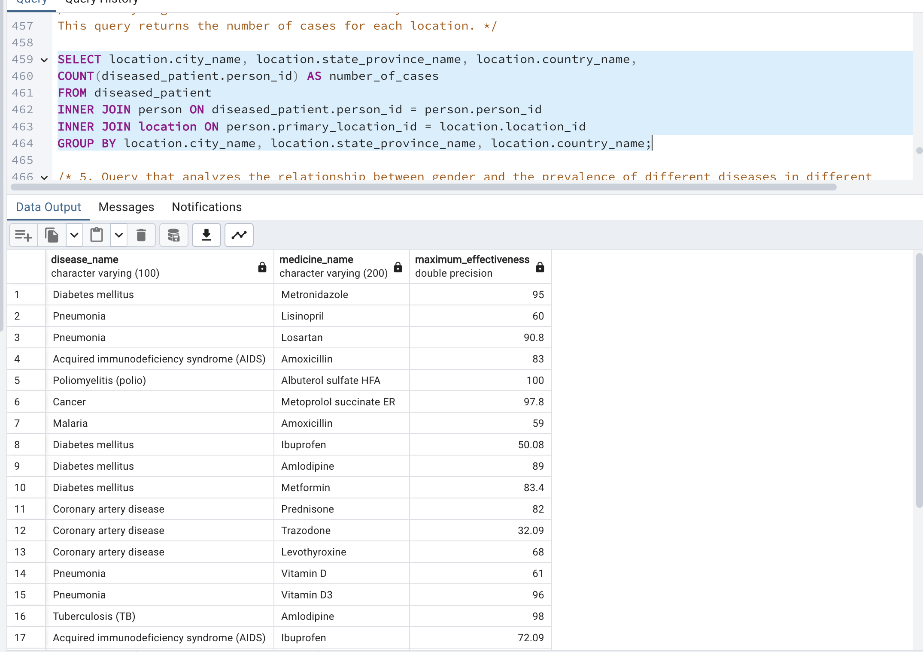**

5. Query that analyzes the relationship between gender and the prevalence of different diseases in different countries:

This query returns the number of cases for each disease, country, and gender combination.

**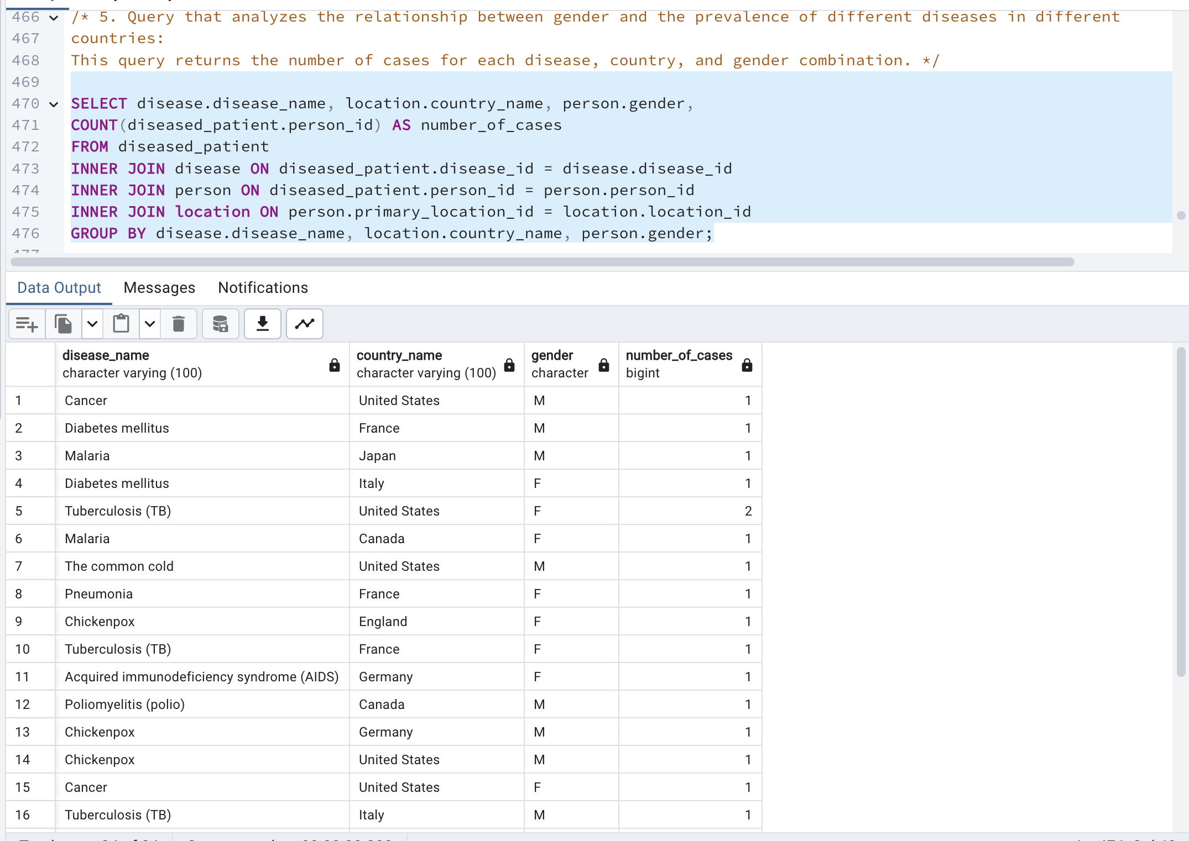**

6. Patient and Medicine Information.

This query returns data about each patient's personal information, location, disease, and the medicine used to treat the disease.

**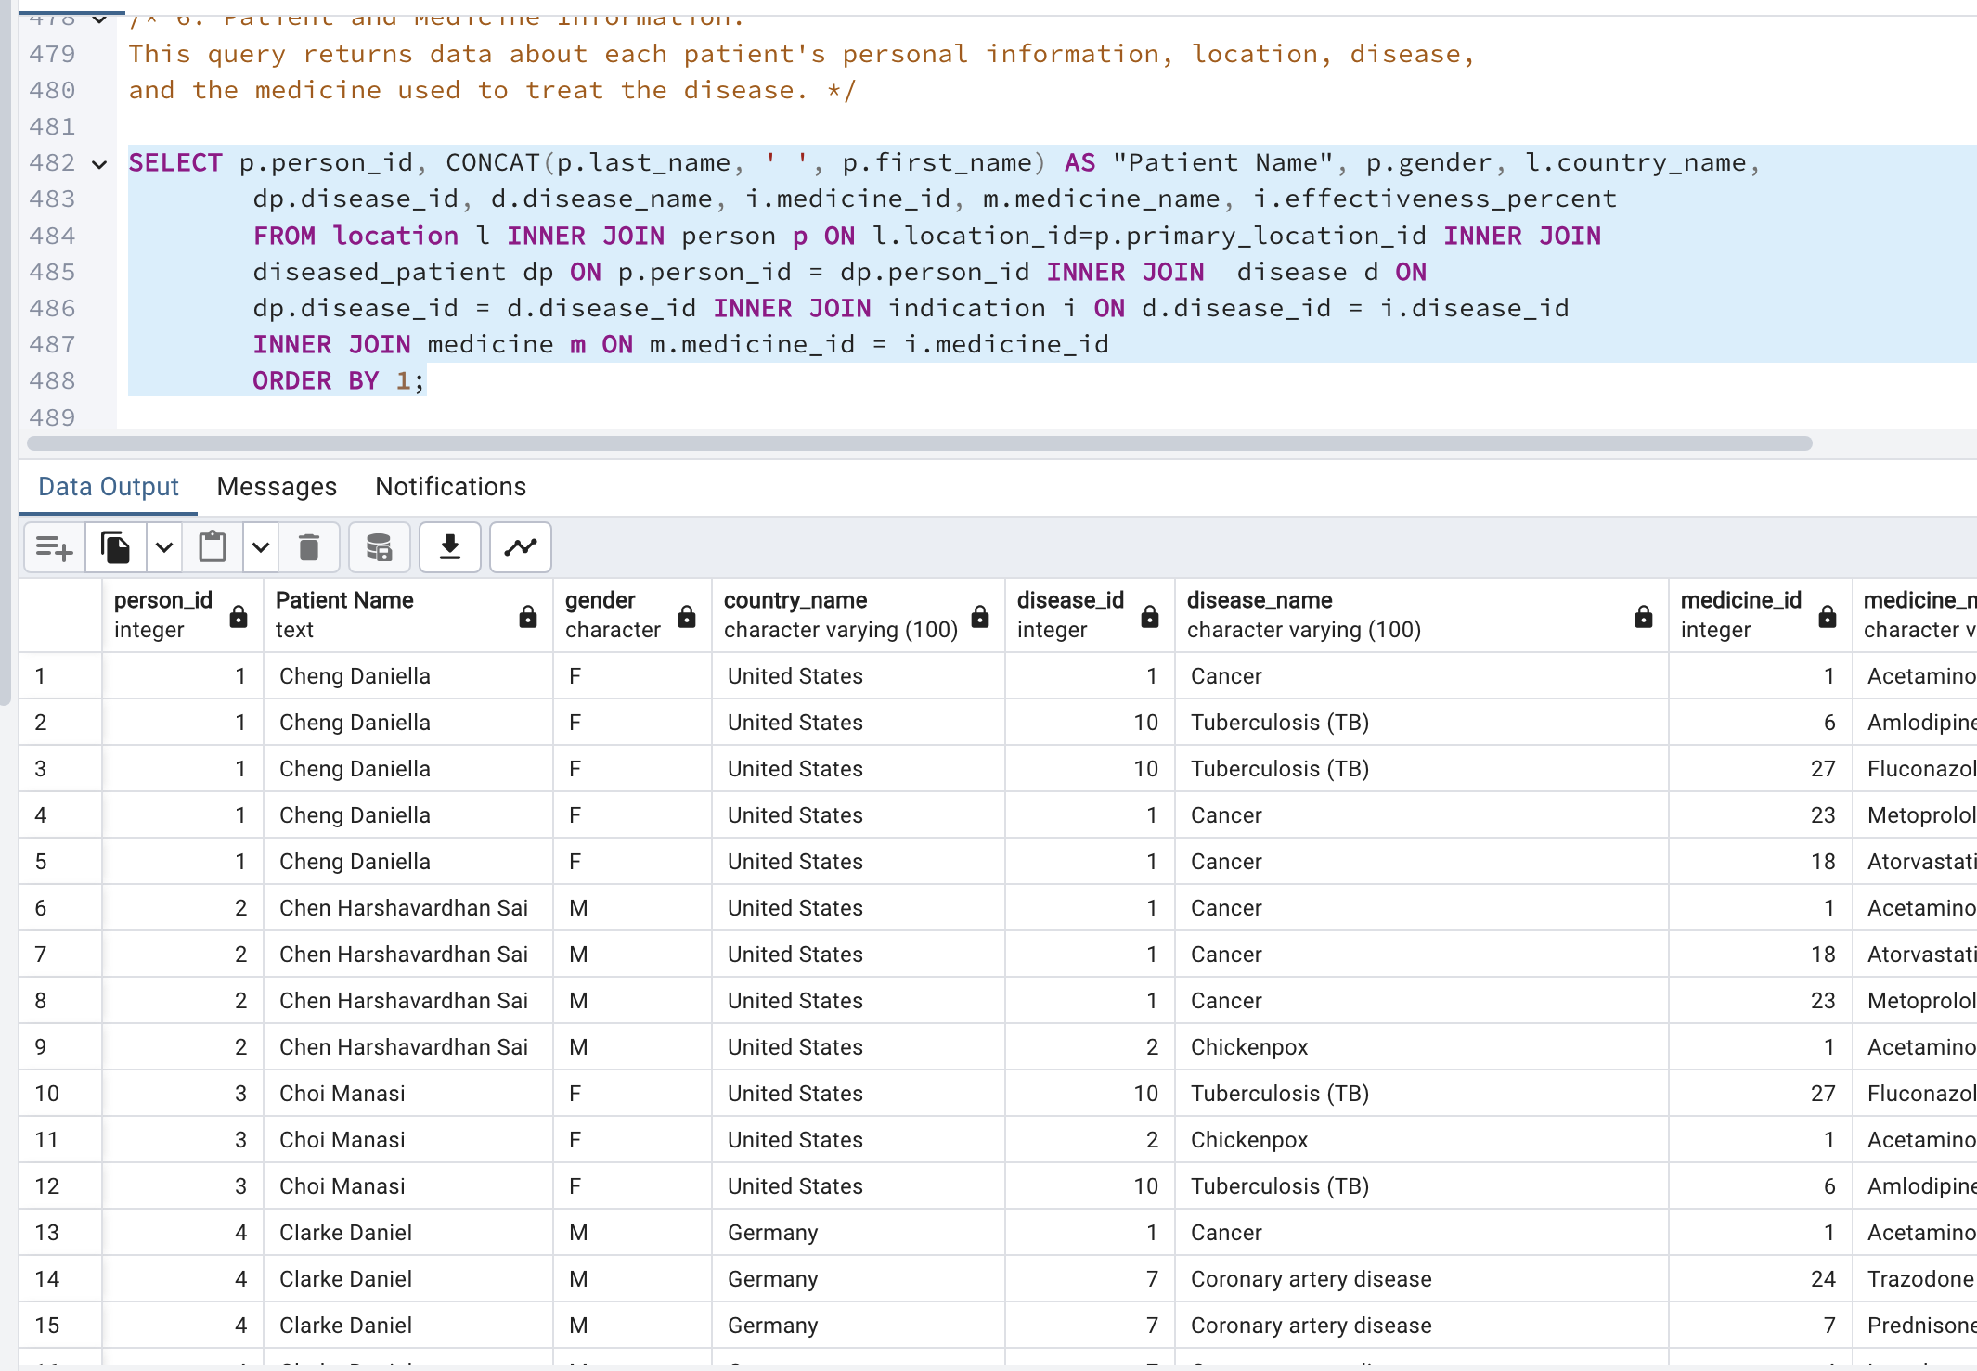**

7. Maximum Medicine Effectiveness for Each Disease

It returns the name of each disease and the name of the medicine with the highest effectiveness percentage

for that disease. The results are grouped by disease name and sorted by disease name and medicine name.

**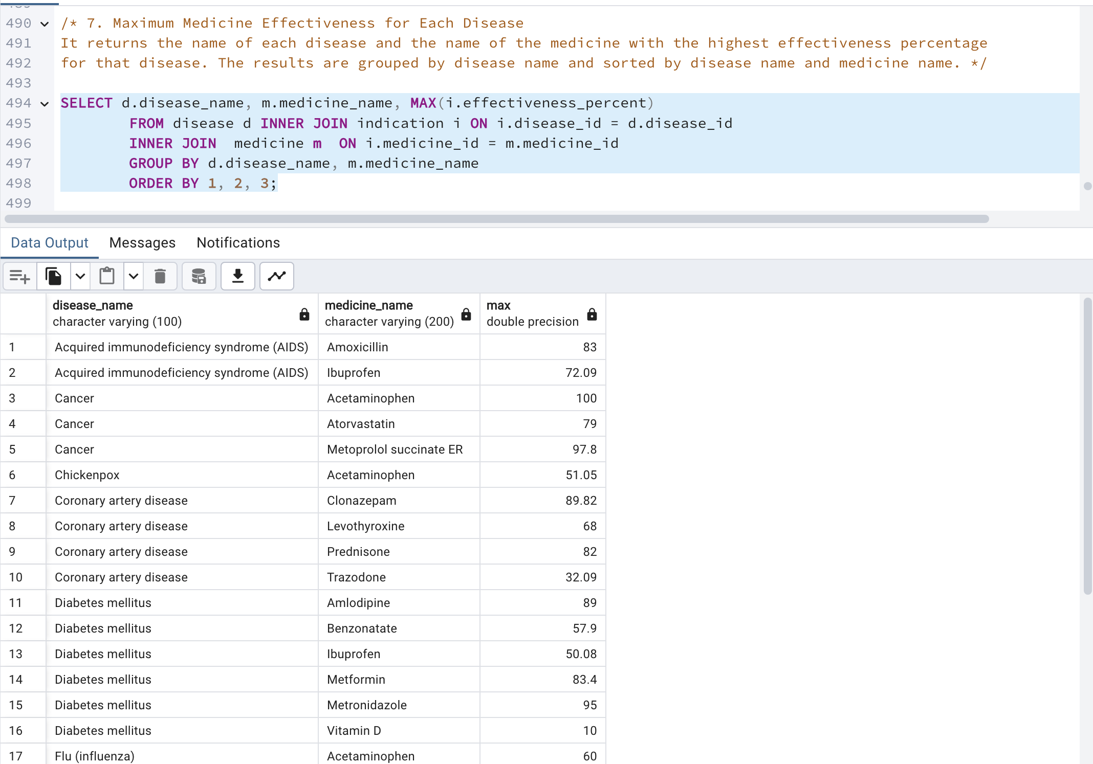**

8. Patient Disease Count by Race

The query returns the data sorted by the count of disease IDs in descending order.

The results are grouped by patient name and race code, and the count of diseases for each group is returned.

**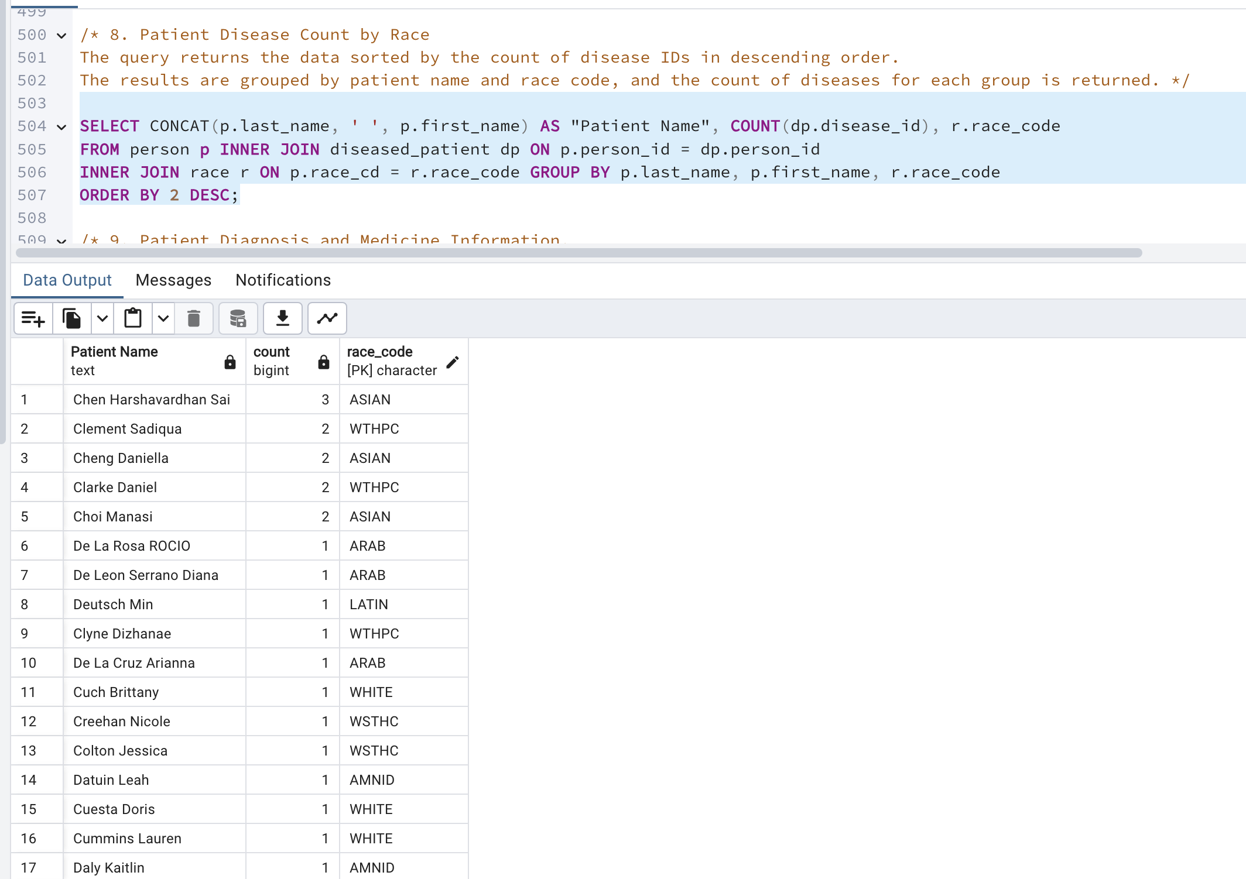**

9. Patient Diagnosis and Medicine Information.

The query returns the data sorted in the order it was retrieved. It returns information about each patient's diagnosis, including the patient's name, age at diagnosis, disease, and the medicine used to treat the

disease. **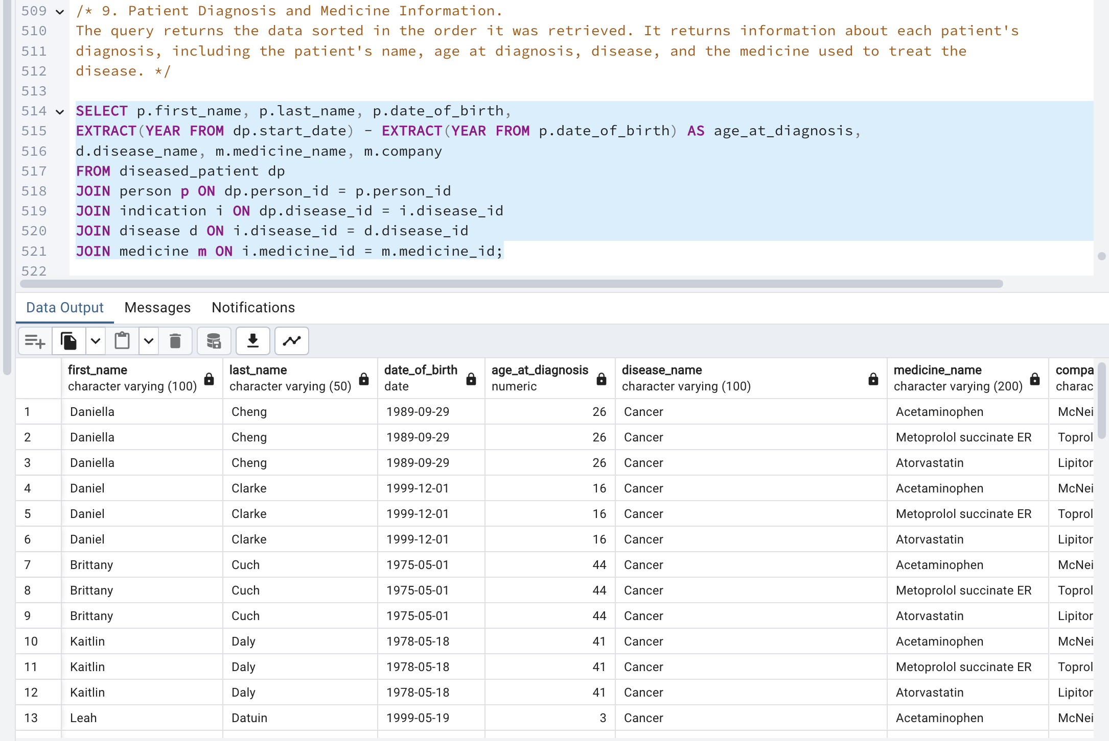**

**Server Side Code**

**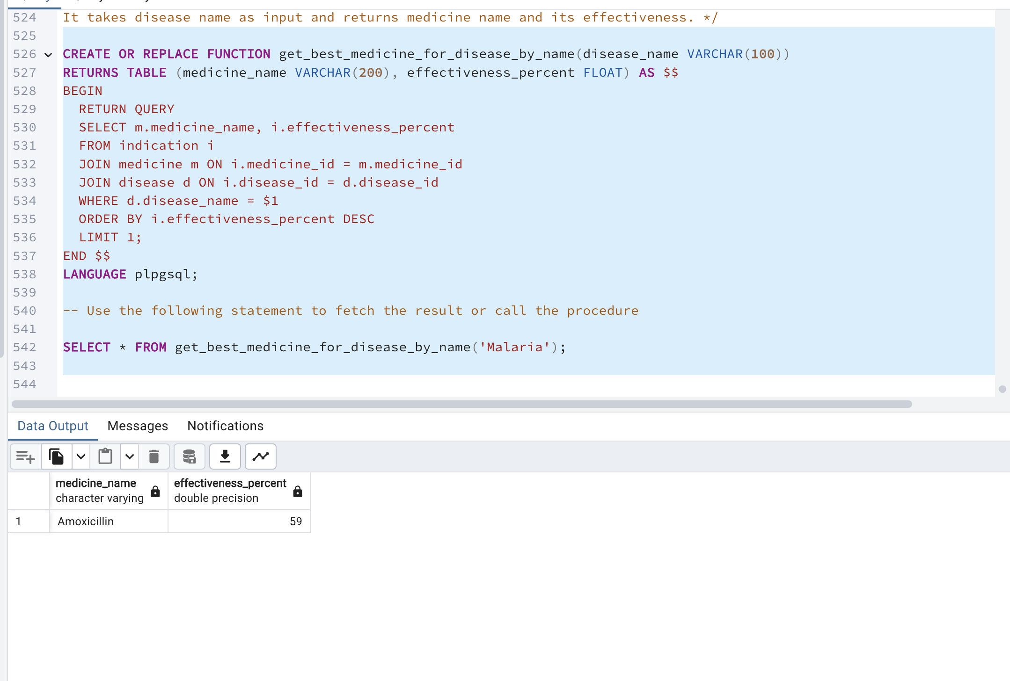**

**Snowflake Disease Model:**

**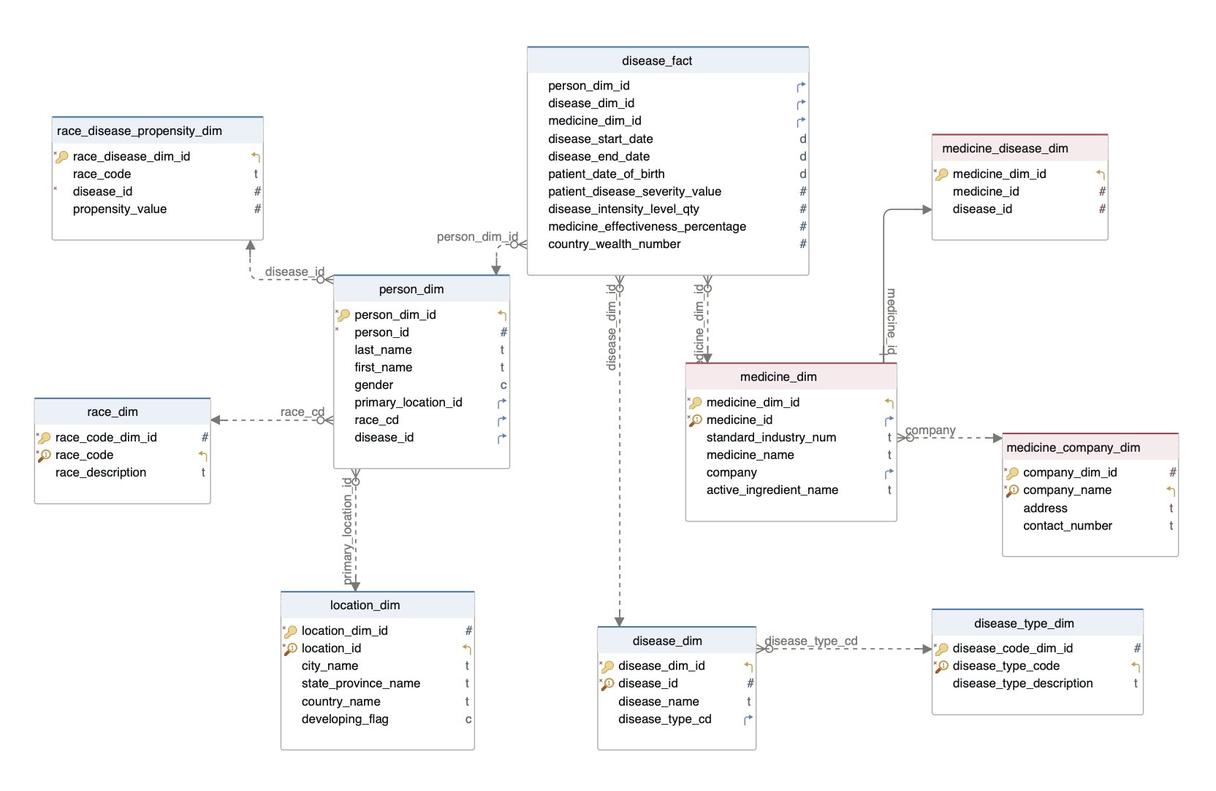**

**DML & DDL Queries:**

CREATE SCHEMA snowflake;

-- creating disease\_type\_dim table in snowflake schema

CREATE TABLE snowflake.disease\_type\_dim

(

disease\_code\_dim\_id int GENERATED ALWAYS AS IDENTITY PRIMARY key,

disease\_type\_code character(5) not null UNIQUE ,

disease\_type\_description character varying(500)

);

-- creating disease\_dim table in snowflake schema

CREATE TABLE snowflake.disease\_dim

(

disease\_dim\_id integer NOT NULL GENERATED ALWAYS AS IDENTITY ,

disease\_id integer not null unique,

disease\_name character varying(100),

disease\_type\_cd character(5),

CONSTRAINT disease\_dim\_pkey PRIMARY KEY (disease\_dim\_id),

CONSTRAINT disease\_type\_fkey FOREIGN KEY (disease\_type\_cd)

REFERENCES snowflake.disease\_type\_dim (disease\_type\_code)

ON UPDATE CASCADE

ON DELETE NO ACTION

);

select \* from snowflake.disease\_dim

--creating race\_disease\_propensity\_dim table in snowflake schema

CREATE TABLE snowflake.race\_disease\_propensity\_dim

(

race\_disease\_dim\_id int GENERATED ALWAYS AS IDENTITY PRIMARY key,

race\_code character varying(5),

disease\_id integer NOT NULL,

propensity\_value integer

);

-- creating location\_dim table in snowflake schema

CREATE TABLE snowflake.location\_dim

(

location\_dim\_id int GENERATED ALWAYS AS IDENTITY PRIMARY key,

location\_id integer NOT NULL UNIQUE,

city\_name character varying(100) ,

state\_province\_name character varying(100),

country\_name character varying(100) ,

developing\_flag character(1)

);

-- creating race\_dim table in snowflake schema

CREATE TABLE snowflake.race\_dim

( race\_code\_dim\_id int GENERATED ALWAYS AS IDENTITY PRIMARY key,

race\_code character(5) not null UNIQUE ,

race\_description character varying(500)

);

-- creating person\_dim table in snowflake schema

CREATE TABLE IF NOT EXISTS snowflake.person\_dim

(

person\_dim\_id integer NOT NULL GENERATED ALWAYS AS IDENTITY ,

person\_id integer NOT NULL,

last\_name character varying(50) ,

first\_name character varying(100) ,

gender character(1),

primary\_location\_id integer,

race\_cd character(5) ,

disease\_id integer,

CONSTRAINT person\_dim\_pkey PRIMARY KEY (person\_dim\_id),

CONSTRAINT disease\_race\_fkey FOREIGN KEY (disease\_id)

REFERENCES snowflake.race\_disease\_propensity\_dim (race\_disease\_dim\_id)

ON UPDATE CASCADE

ON DELETE NO ACTION,

CONSTRAINT location\_type\_fkey FOREIGN KEY (primary\_location\_id)

REFERENCES snowflake.location\_dim (location\_id)

ON UPDATE CASCADE

ON DELETE NO ACTION,

CONSTRAINT race\_cd\_fkey FOREIGN KEY (race\_cd)

REFERENCES snowflake.race\_dim (race\_code)

ON UPDATE CASCADE

ON DELETE NO ACTION

);

-- creating medicine\_disease\_dim table in snowflake schema

CREATE TABLE snowflake.medicine\_disease\_dim

(

medicine\_dim\_id int GENERATED ALWAYS AS IDENTITY PRIMARY key ,

medicine\_id integer ,

disease\_id integer

);

-- creating medicine\_dim table in snowflake schema

CREATE TABLE IF NOT EXISTS snowflake.medicine\_dim

(

medicine\_dim\_id integer NOT NULL GENERATED ALWAYS AS IDENTITY ,

medicine\_id integer not null unique,

standard\_industry\_num character varying(30) ,

medicine\_name character varying(200) ,

company character varying(150) ,

active\_ingredient\_name character varying(200),

CONSTRAINT medicine\_dim\_pkey PRIMARY KEY (medicine\_dim\_id),

CONSTRAINT company\_name\_fkey FOREIGN KEY (company)

REFERENCES snowflake.medicine\_company\_dim (company\_name)

ON UPDATE NO ACTION

ON DELETE NO ACTION,

CONSTRAINT medicine\_id\_fkey FOREIGN KEY (medicine\_id)

REFERENCES snowflake.medicine\_disease\_dim (medicine\_dim\_id)

ON UPDATE NO ACTION

ON DELETE NO ACTION

);

/\* Some of the alter statements to add and drop foreign key constraint

-- Altering medicine\_dim table in snowflake to add foreign\_key constraint

alter table snowflake.medicine\_dim add constraint medicine\_id\_fkey

FOREIGN KEY (medicine\_dim\_id)

REFERENCES snowflake.medicine\_disease\_dim (medicine\_dim\_id) ;

alter table snowflake.medicine\_dim add

CONSTRAINT company\_name\_fkey FOREIGN KEY (company)

REFERENCES snowflake.medicine\_company\_dim (company\_name) ;

alter table snowflake.medicine\_dim add CONSTRAINT medecine\_disease\_fkey FOREIGN KEY (disease\_id)

REFERENCES snowflake.medicine\_effective\_disease\_dim (disease\_id); \*/

-- creating medicine\_company\_dim table in snowflake schema

CREATE TABLE snowflake.medicine\_company\_dim

(

company\_dim\_id int GENERATED ALWAYS AS IDENTITY PRIMARY key,

company\_name character varying(200) not null unique,

address character varying(250),

contact\_number character varying(30)

);

-- creating disease\_fact table in snowflake schema

CREATE TABLE snowflake.disease\_fact

(

person\_dim\_id integer,

disease\_dim\_id integer,

medicine\_dim\_id integer,

disease\_start\_date date,

disease\_end\_date date,

patient\_date\_of\_birth date,

patient\_disease\_severity\_value integer,

disease\_intensity\_level\_qty integer,

medicine\_effectiveness\_percentage double precision,

country\_wealth\_number integer,

CONSTRAINT disease\_dim\_id\_fkey FOREIGN KEY (disease\_dim\_id)

REFERENCES snowflake.disease\_dim (disease\_dim\_id)

ON UPDATE CASCADE

ON DELETE NO ACTION,

CONSTRAINT medicine\_dim\_id\_fkey FOREIGN KEY (medicine\_dim\_id)

REFERENCES snowflake.medicine\_dim (medicine\_dim\_id)

ON UPDATE CASCADE

ON DELETE NO ACTION,

CONSTRAINT person\_dim\_id\_fkey FOREIGN KEY (person\_dim\_id)

REFERENCES snowflake.person\_dim (person\_dim\_id)

ON UPDATE CASCADE

ON DELETE NO ACTION

);

Loading the data ETL (or ELT) process

/\* Inserting data into snowflake dimension table using select subquery into insert statement.

This process is also know ETL or ELT to move data from OLTP to Snowflake Schema(Datawarehouse) \*/

-- Insert Data into Snowflake.disease\_type\_dim dimenstional table

insert into snowflake.disease\_type\_dim (disease\_type\_code, disease\_type\_description)

select disease\_type\_code, disease\_type\_description from public.disease\_type;

-- Insert Data into Snowflake.disease\_dim dimenstional table

insert into snowflake.disease\_dim(disease\_id, disease\_name,disease\_type\_cd)

select disease\_id, disease\_name,disease\_type\_cd

from public.disease;

-- Insert Data into Snowflake.race\_dim dimenstional table

insert into snowflake.race\_dim(race\_code, race\_description)

select race\_code, race\_description from public.race;

-- Insert Data into Snowflake.race\_disease\_propensity\_dim dimenstional table

insert into snowflake.race\_disease\_propensity\_dim (race\_code, disease\_id, propensity\_value)

select race\_code, disease\_id, propensity\_value from public.race\_disease\_propensity ;

---- Insert Data into Snowflake.location\_dim dimenstional table

insert into snowflake.location\_dim(location\_id, city\_name, state\_province\_name,

country\_name, developing\_flag)

select location\_id, city\_name, state\_province\_name, country\_name, developing\_flag

from public."location" ;

-- Inserting data into person\_dim dimensional table

insert into snowflake.person\_dim (person\_id, last\_name,first\_name,gender,primary\_location\_id,race\_cd,

disease\_id)

select p.person\_id, p.last\_name,p.first\_name,p.gender,p.primary\_location\_id,p.race\_cd,dp.disease\_id

from public.person p inner join public.diseased\_patient dp on

p.person\_id = dp.person\_id ;

-- Insert Data into Snowflake.medicine\_disease\_dim dimenstional table

insert into snowflake.medicine\_disease\_dim(medicine\_id,disease\_id)

select medicine\_id,disease\_id from public.indication ;

-- Inserting data into medicine\_company\_dim

insert into snowflake.medicine\_company\_dim(Company\_name, Address, Contact\_Number) Values

('McNeil Consumer Healthcare', '9704 Huntmaster Rd', +13473998637);

insert into snowflake.medicine\_company\_dim(Company\_name, Address, Contact\_Number) Values

('Drisdol', '21110 Dwyer Ct', +15566670722);

insert into snowflake.medicine\_company\_dim(Company\_name, Address, Contact\_Number) Values

('Motrin', '9101 Warfield Rd', +13498995561);

insert into snowflake.medicine\_company\_dim(Company\_name, Address, Contact\_Number) Values

('Synthroid','8531 Plum Creek Dr', +19992323990);

insert into snowflake.medicine\_company\_dim(Company\_name, Address, Contact\_Number) Values

('Prinivil', '7913 Windsor Knoll Ln', +18823207159);

insert into snowflake. medicine\_company\_dim(Company\_name, Address, Contact\_Number) Values

('Norvasc', '8301 Lando Ct', +18462650161);

insert into snowflake.medicine\_company\_dim(Company\_name, Address, Contact\_Number) Values

('Deltasone', '20931 Goshen Rd', +18428171239);

insert into snowflake.medicine\_company\_dim(Company\_name, Address, Contact\_Number) Values

('Adderall', '21313 Bourdeaux Pl', +18298215889);

insert into snowflake.medicine\_company\_dim(Company\_name, Address, Contact\_Number) Values

('Ventolin HFA', '8630 Lochaven Dr', +17692842317);

insert into snowflake.medicine\_company\_dim(Company\_name, Address, Contact\_Number) Values

('Xanax', '22100 Creekview Dr', +17013723020);

insert into snowflake.medicine\_company\_dim(Company\_name, Address, Contact\_Number) Values

('Flexeril', '21020 Brink Ct', +16595107237);

insert into snowflake.medicine\_company\_dim(Company\_name, Address, Contact\_Number) Values

('Zithromax Z-Pak', '8401 Warfield Rd', +16426991951);

insert into snowflake.medicine\_company\_dim(Company\_name, Address, Contact\_Number) Values

('Neurontin', '22101 Goshen School Rd', +16301267038);

insert into snowflake.medicine\_company\_dim(Company\_name, Address, Contact\_Number) Values

('Keflex', '21536 Quick Fox Ln', +16167941966);

insert into snowflake.medicine\_company\_dim(Company\_name, Address, Contact\_Number) Values

('Zyrtec', '8504 Churchill Downs Rd', +15855864871);

insert into snowflake.medicine\_company\_dim(Company\_name, Address, Contact\_Number) Values

('Microzide', '21624 Goshen Oaks Rd', +15326349557);

insert into snowflake.medicine\_company\_dim(Company\_name, Address, Contact\_Number) Values

('Glucophage', '7921 Windsor Knoll Ln', +15060994723);

insert into snowflake.medicine\_company\_dim(Company\_name, Address, Contact\_Number) Values

('Lipitor', '20601 Miracle Dr', +14548303184);

insert into snowflake.medicine\_company\_dim(Company\_name, Address, Contact\_Number) Values

('Augmentin', '20812 Apollo Ln', +14528786671);

insert into snowflake.medicine\_company\_dim(Company\_name, Address, Contact\_Number) Values

('D3-50', '22105 Creekview Dr', +14418232107);

insert into snowflake.medicine\_company\_dim(Company\_name, Address, Contact\_Number) Values

('Tessalon Perles', '8813 Goshen Mill Ct', +14418232107);

insert into snowflake.medicine\_company\_dim(Company\_name, Address, Contact\_Number) Values

('Cozaar', '9 Foxlair Ct', +14060034724);

insert into snowflake.medicine\_company\_dim(Company\_name, Address, Contact\_Number) Values

('Toprol XL', '9137 Goshen Valley Dr', +13846228768);

insert into snowflake.medicine\_company\_dim(Company\_name, Address, Contact\_Number) Values

('Desyrel', '8508 Plum Creek Dr', +13846228768);

insert into snowflake.medicine\_company\_dim(Company\_name, Address, Contact\_Number) Values

('Klonopin', '9117 Goshen Valley Dr', +13815450810);

insert into snowflake.medicine\_company\_dim(Company\_name, Address, Contact\_Number) Values

('Ambien', '22713 Robin Ct', +13676834865);

insert into snowflake.medicine\_company\_dim(Company\_name, Address, Contact\_Number) Values

('Diflucan', '8505 Churchill Downs Rd', +13596259824);

insert into snowflake.medicine\_company\_dim(Company\_name, Address, Contact\_Number) Values

('Flagyl', '22308 Bertie Farm Ct', +13423322614);

insert into snowflake.medicine\_company\_dim(Company\_name, Address, Contact\_Number) Values

('Lasix', '22521 Sweetleaf Ln', +13351514273);

insert into snowflake.medicine\_company\_dim(Company\_name, Address, Contact\_Number) Values

('ferrous sulfate', '21628 Goshen Oaks Rd', +13278483984);

-- Insert Data into Snowflake.medicine\_dim dimenstional table

insert into snowflake.medicine\_dim(medicine\_id , standard\_industry\_num , medicine\_name ,

company,active\_ingredient\_name )

select medicine\_id , standard\_industry\_num , medicine\_name , company,

active\_ingredient\_name from public.medicine limit 25 ;

-- Inserting data into Disease\_fact Table

insert into snowflake.disease\_fact( person\_dim\_id, disease\_dim\_id, medicine\_dim\_id,

disease\_start\_date, disease\_end\_date, patient\_date\_of\_birth,

patient\_disease\_severity\_value, disease\_intensity\_level\_qty,

medicine\_effectiveness\_percentage, country\_wealth\_number)

select p.person\_id, d.disease\_id, m.medicine\_id,

dp.start\_date, dp.end\_date, p.date\_of\_birth,

dp.severity\_value, d.intensity\_level\_qty, i.effectiveness\_percent, l.wealth\_rank\_number

from public.diseased\_patient dp

inner join public.person p on dp.person\_id = p.person\_id

inner join public.disease d on dp.disease\_id = d.disease\_id

inner join public.indication i ON i.disease\_id = d.disease\_id

inner join public.medicine m ON m.medicine\_id = i.medicine\_id

inner join public."location" l ON l.location\_id = p.primary\_location\_id

where m.medicine\_id < 26;

-- Querying Disease\_fact table

select \* from snowflake.disease\_fact order by 1,2,3

-- Interesting analyses that can be generate from snowflake schema

/\* To get a list of all the locations in the location\_dim table,

along with the number of people living in each location\*/

SELECT l.city\_name, l.state\_province\_name, l.country\_name,

COUNT(p.person\_dim\_id) AS num\_people

FROM snowflake.location\_dim l

LEFT JOIN snowflake.person\_dim p

ON l.location\_id = p.primary\_location\_id

GROUP BY l.city\_name, l.state\_province\_name, l.country\_name;

/\* List of all the medicines in the medicine\_dim table, along with the names of the companies that

manufacture them.\*/

SELECT m.medicine\_name, mc.company\_name

FROM snowflake.medicine\_dim m

INNER JOIN snowflake.medicine\_company\_dim mc

ON m.company = mc.company\_name;

/\*. List of all the racial groups in the race\_dim table, along with their propensity values for a specific disease\*/

SELECT r.race\_code, rd.propensity\_value

FROM snowflake.race\_dim r

INNER JOIN snowflake.race\_disease\_propensity\_dim rd

ON r.race\_code = rd.race\_code

WHERE rd.disease\_id = 1;

-- To get the top 10 diseases by total cases, with their respective disease types:

SELECT d.disease\_id, d.disease\_type\_cd, d.disease\_name, COUNT(\*) AS total\_cases

FROM snowflake.disease\_fact df inner join snowflake.disease\_dim d

ON df.disease\_dim\_id = d.disease\_dim\_id

GROUP BY d.disease\_id, d.disease\_name, d.disease\_type\_cd

ORDER BY total\_cases DESC

LIMIT 10

-- To get the total number of cases of each disease, grouped by location and year:

SELECT l.country\_name, COUNT(\*) AS total\_cases

FROM snowflake.location\_dim l inner join snowflake.person\_dim p on l.location\_id = p.primary\_location\_id

inner join snowflake.disease\_fact df ON df.person\_dim\_id = p.person\_dim\_id

group by l.country\_name

/\* The query will provide a summary of the diseases and medicines that are being used by people, grouped by gender and organized by the disease, medicine, and company \*/

SELECT p.gender, COUNT(d.disease\_id) AS total\_diseases, d.disease\_name, m.medicine\_name,

mcd.company\_name, mcd.contact\_number

FROM snowflake.person\_dim p

JOIN snowflake.disease\_dim d ON p.disease\_id = d.disease\_dim\_id

JOIN snowflake.medicine\_disease\_dim md ON d.disease\_dim\_id = md.disease\_id

JOIN snowflake.medicine\_dim m ON md.medicine\_id = m.medicine\_dim\_id

JOIN snowflake.medicine\_company\_dim mcd ON m.company = mcd.company\_name

GROUP BY p.gender, d.disease\_name, m.medicine\_name, mcd.company\_name, mcd.contact\_number;

-- Created a view named "disease\_medicine\_view" for the above select statement

CREATE VIEW disease\_medicine\_view AS

SELECT p.gender, COUNT(d.disease\_id) AS total\_diseases, d.disease\_name, m.medicine\_name,

mcd.company\_name, mcd.contact\_number

FROM snowflake.person\_dim p

JOIN snowflake.disease\_dim d ON p.disease\_id = d.disease\_dim\_id

JOIN snowflake.medicine\_disease\_dim md ON d.disease\_dim\_id = md.disease\_id

JOIN snowflake.medicine\_dim m ON md.medicine\_id = m.medicine\_dim\_id

JOIN snowflake.medicine\_company\_dim mcd ON m.company = mcd.company\_name

GROUP BY p.gender, d.disease\_name, m.medicine\_name, mcd.company\_name, mcd.contact\_number;

Select \* from disease\_medicine\_view;

**Analytical queries:**

1. To get a list of all the locations in the location\_dim table, along with the number of people living in each location

**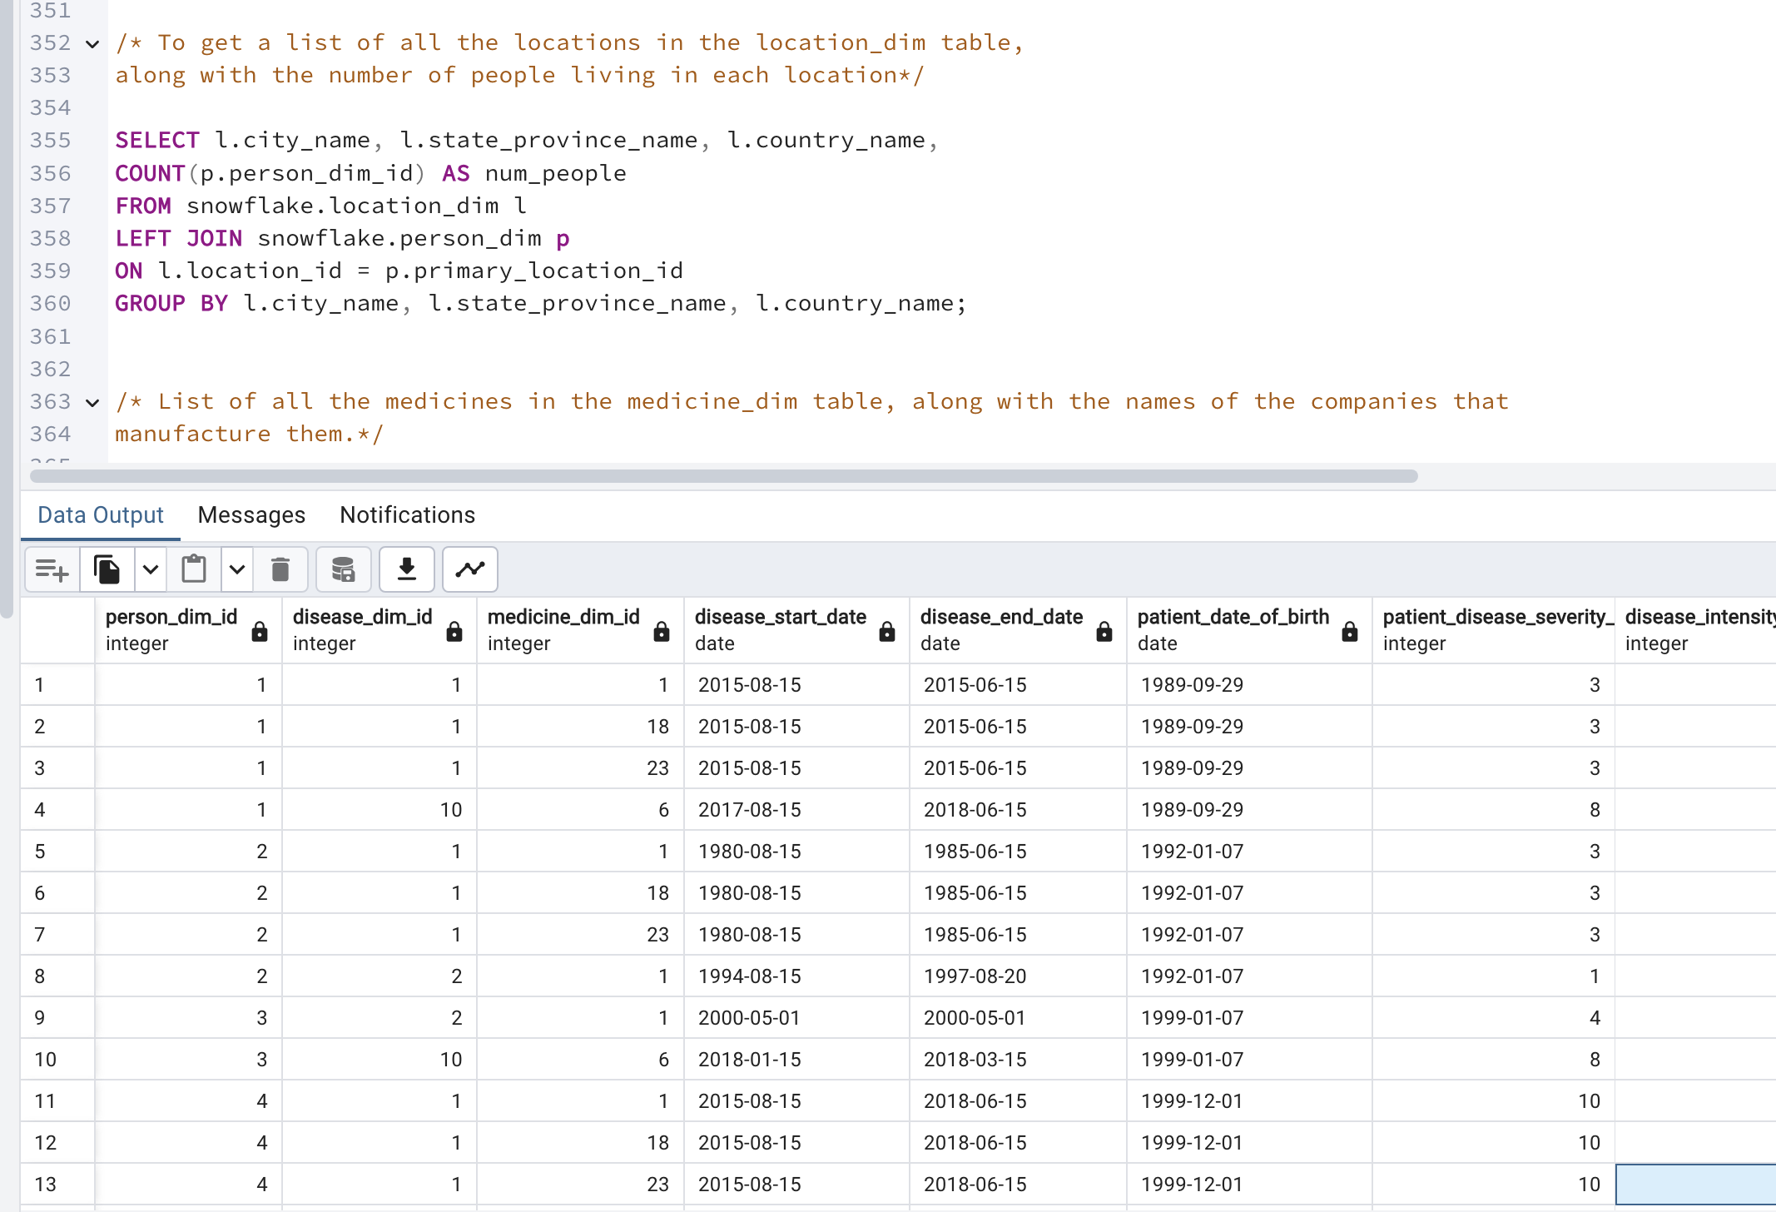**

2. List of all the medicines in the medicine\_dim table, along with the names of the companies that manufacture them.

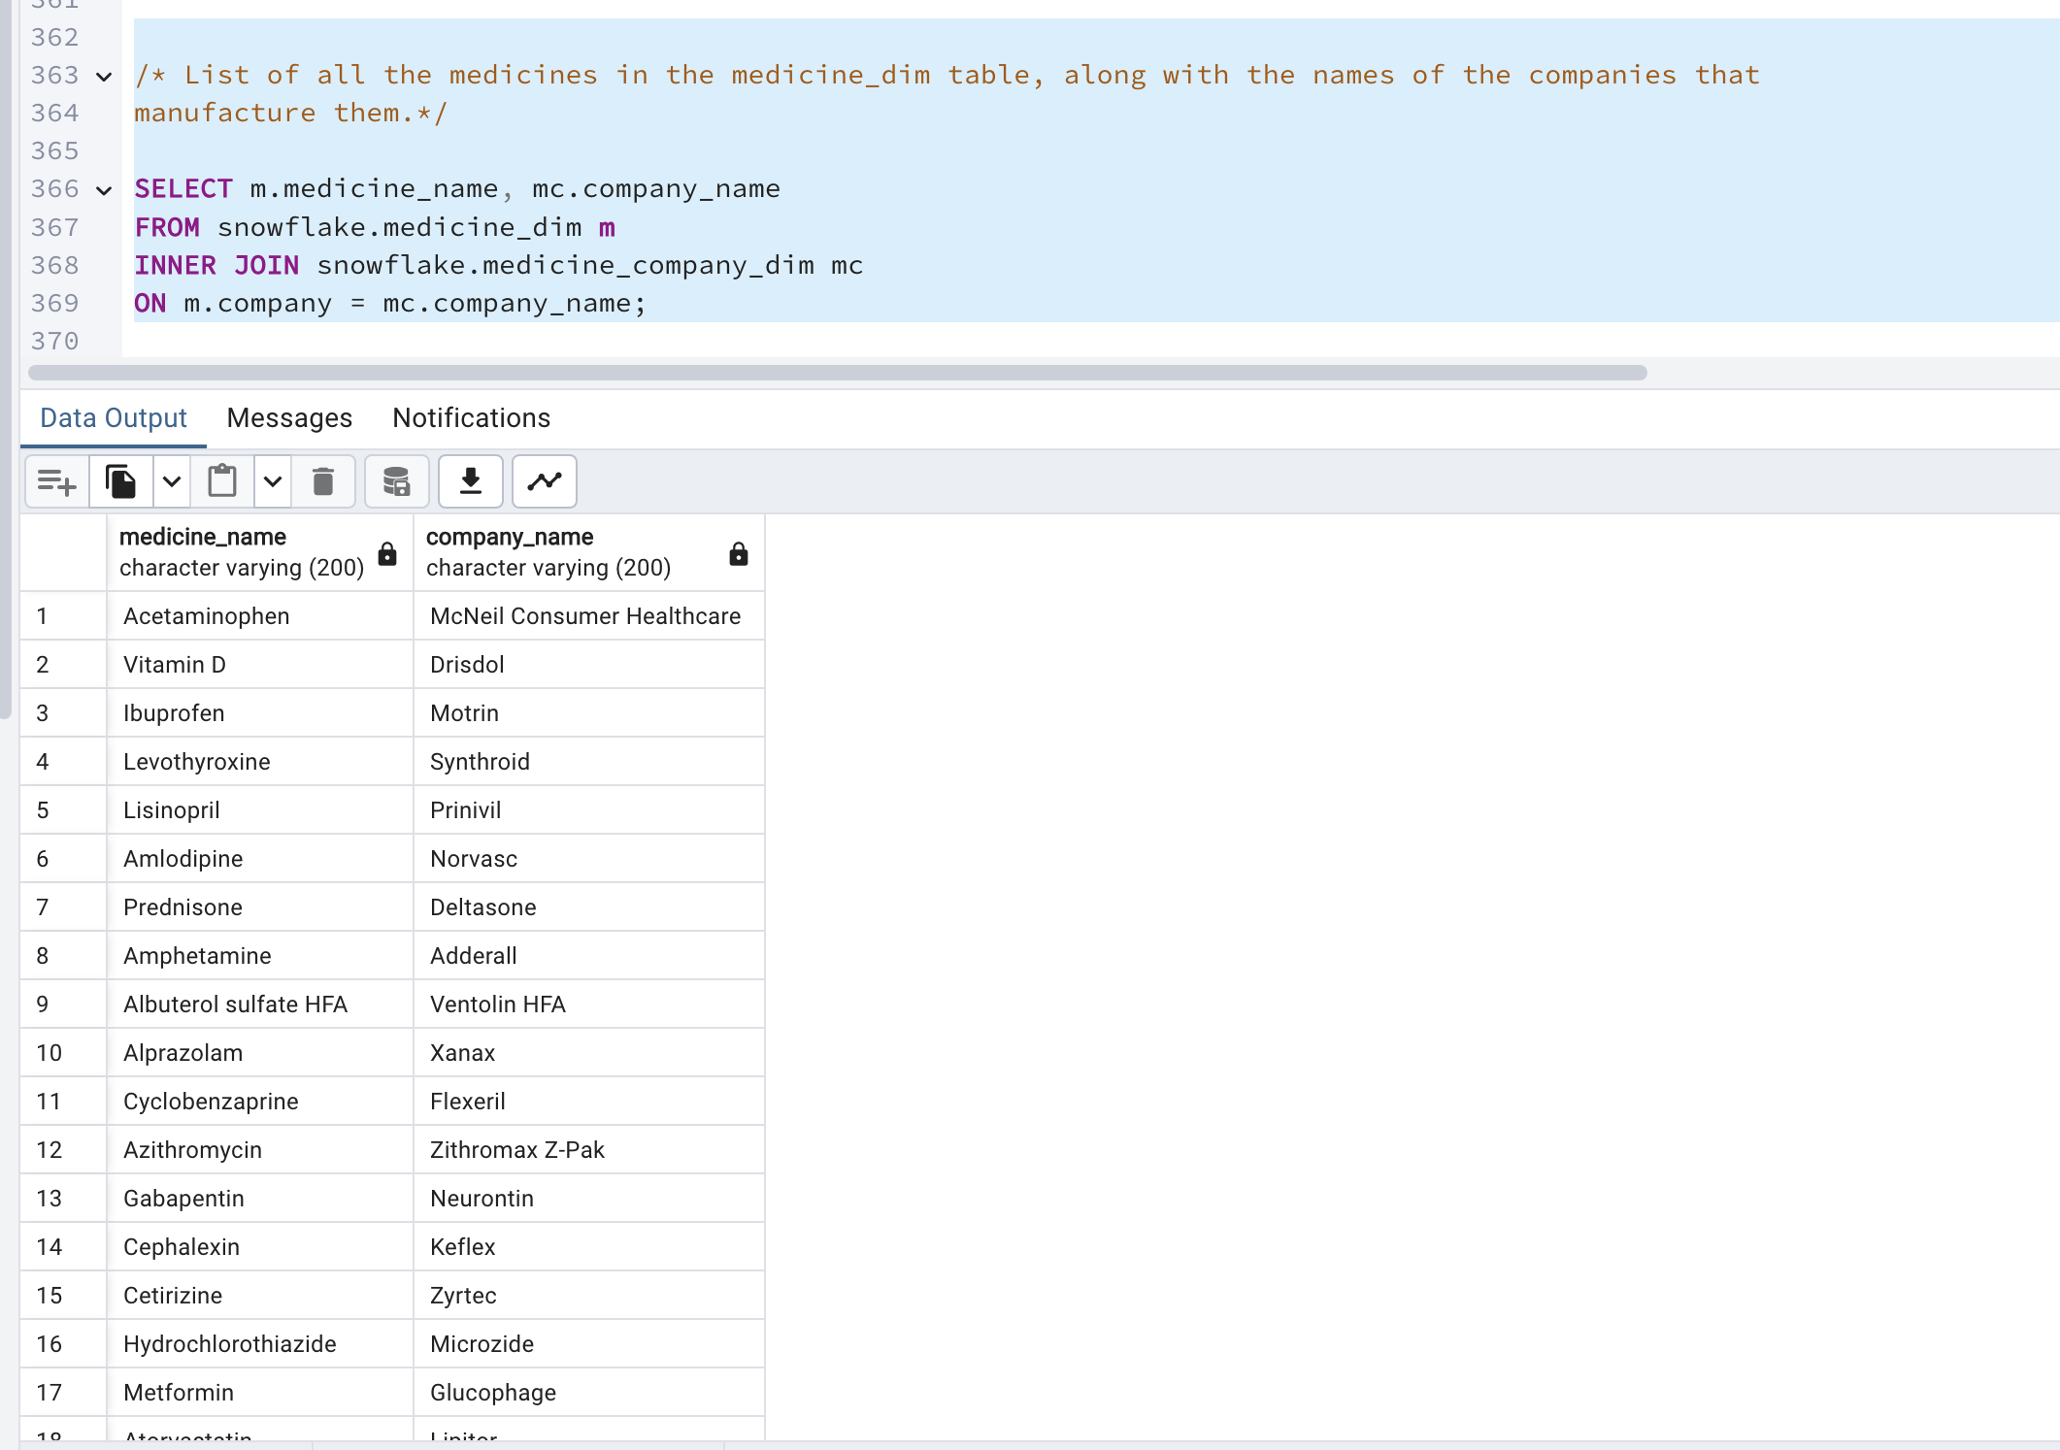

3. List of all the racial groups in the race\_dim table, along with their propensity values for a specific disease.

**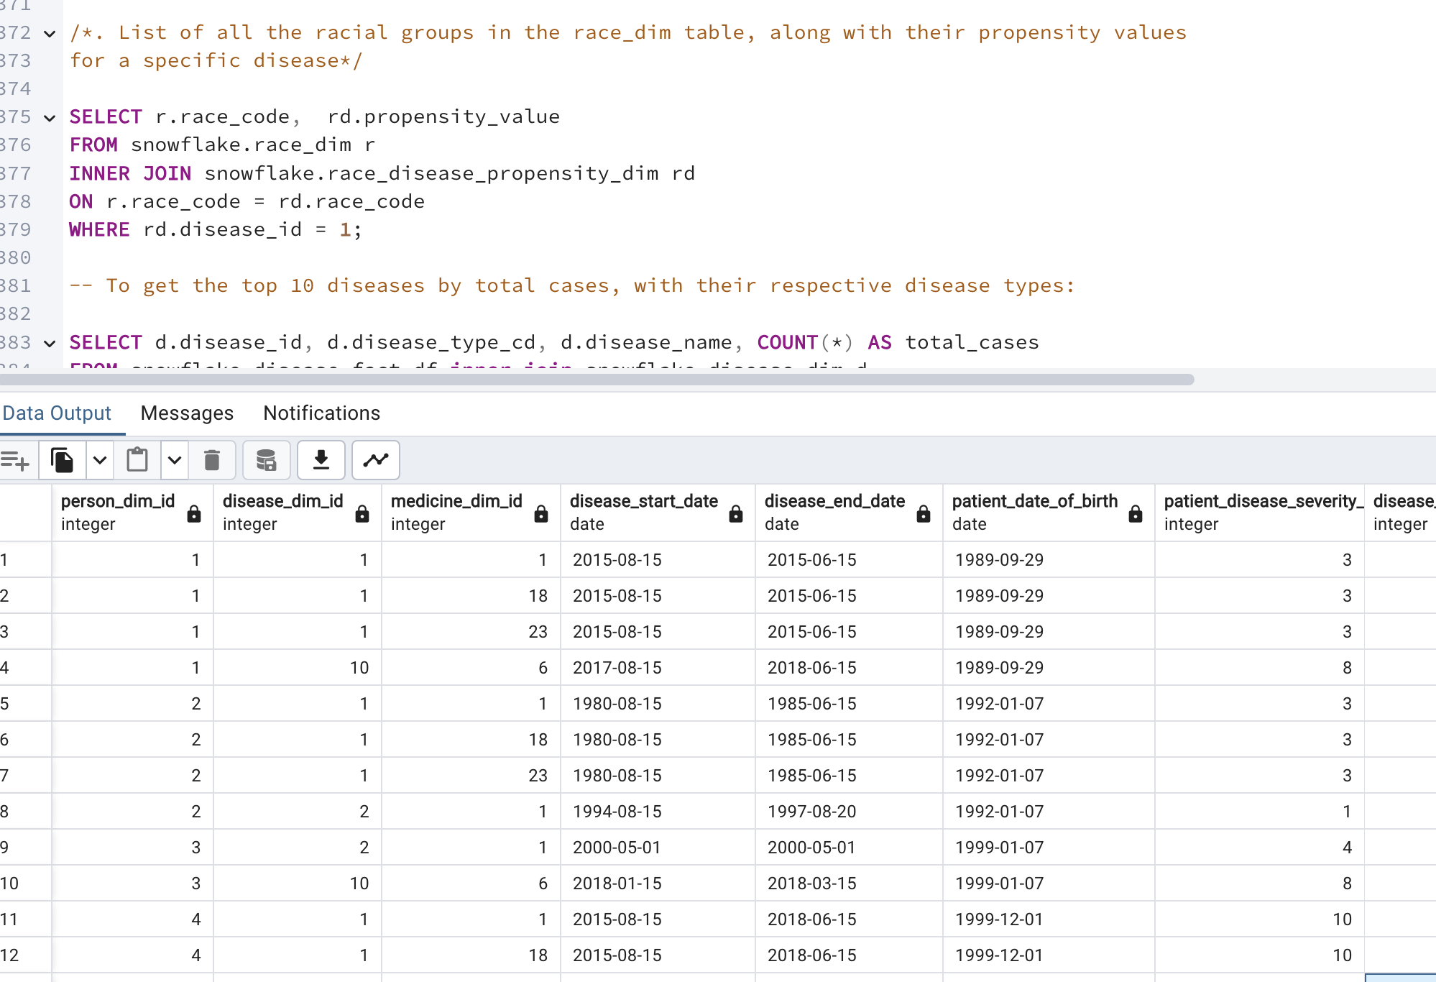**

4. To get the top 10 diseases by total cases, with their respective disease types:

**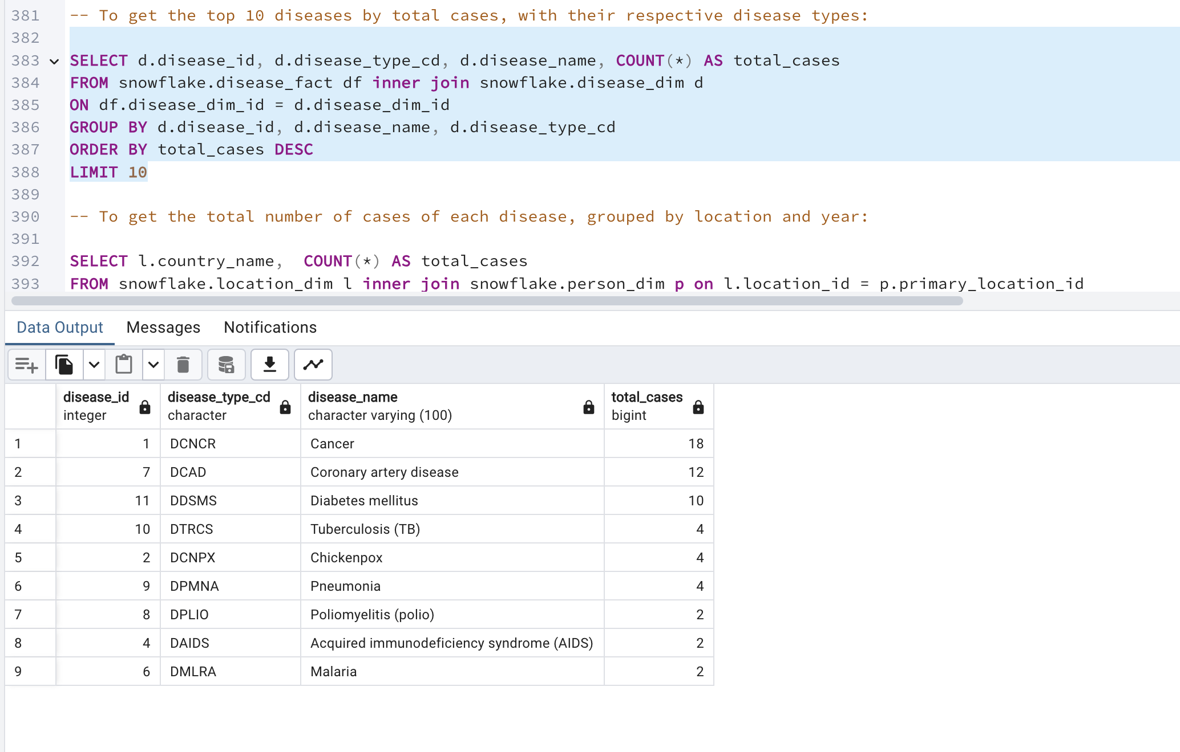**

5. To get the total number of cases of each disease, grouped by location and year:

**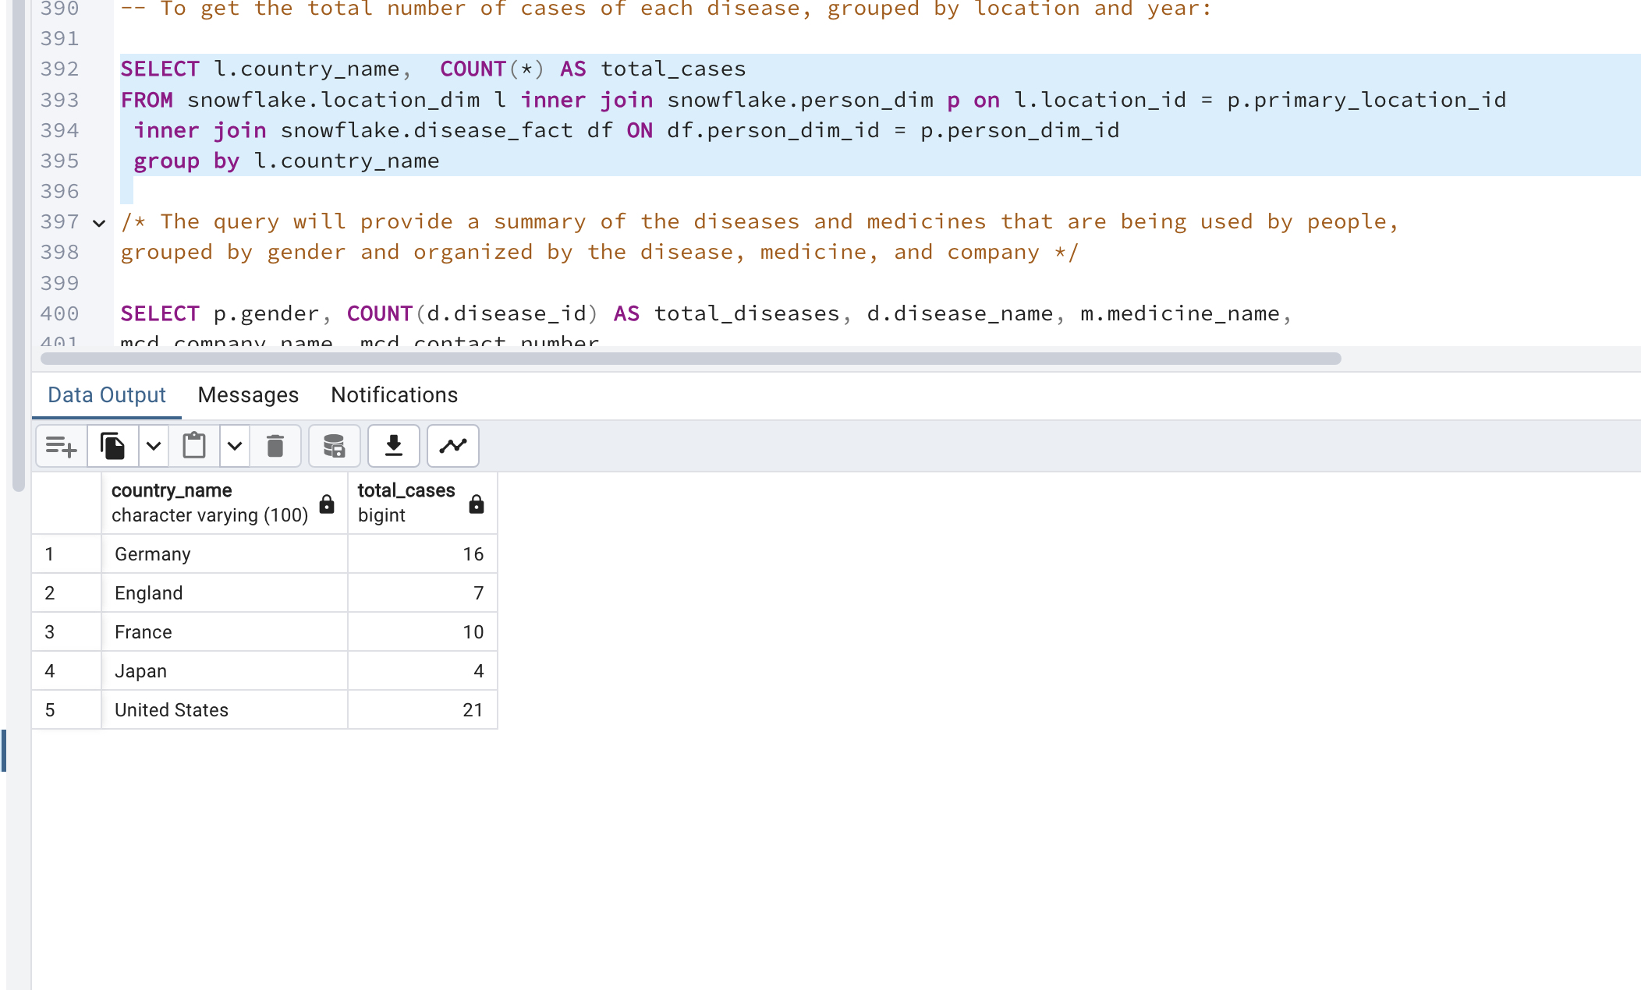**

6. The query will provide a summary of the diseases and medicines that are being used by people, grouped by gender and organized by the disease, medicine, and company

**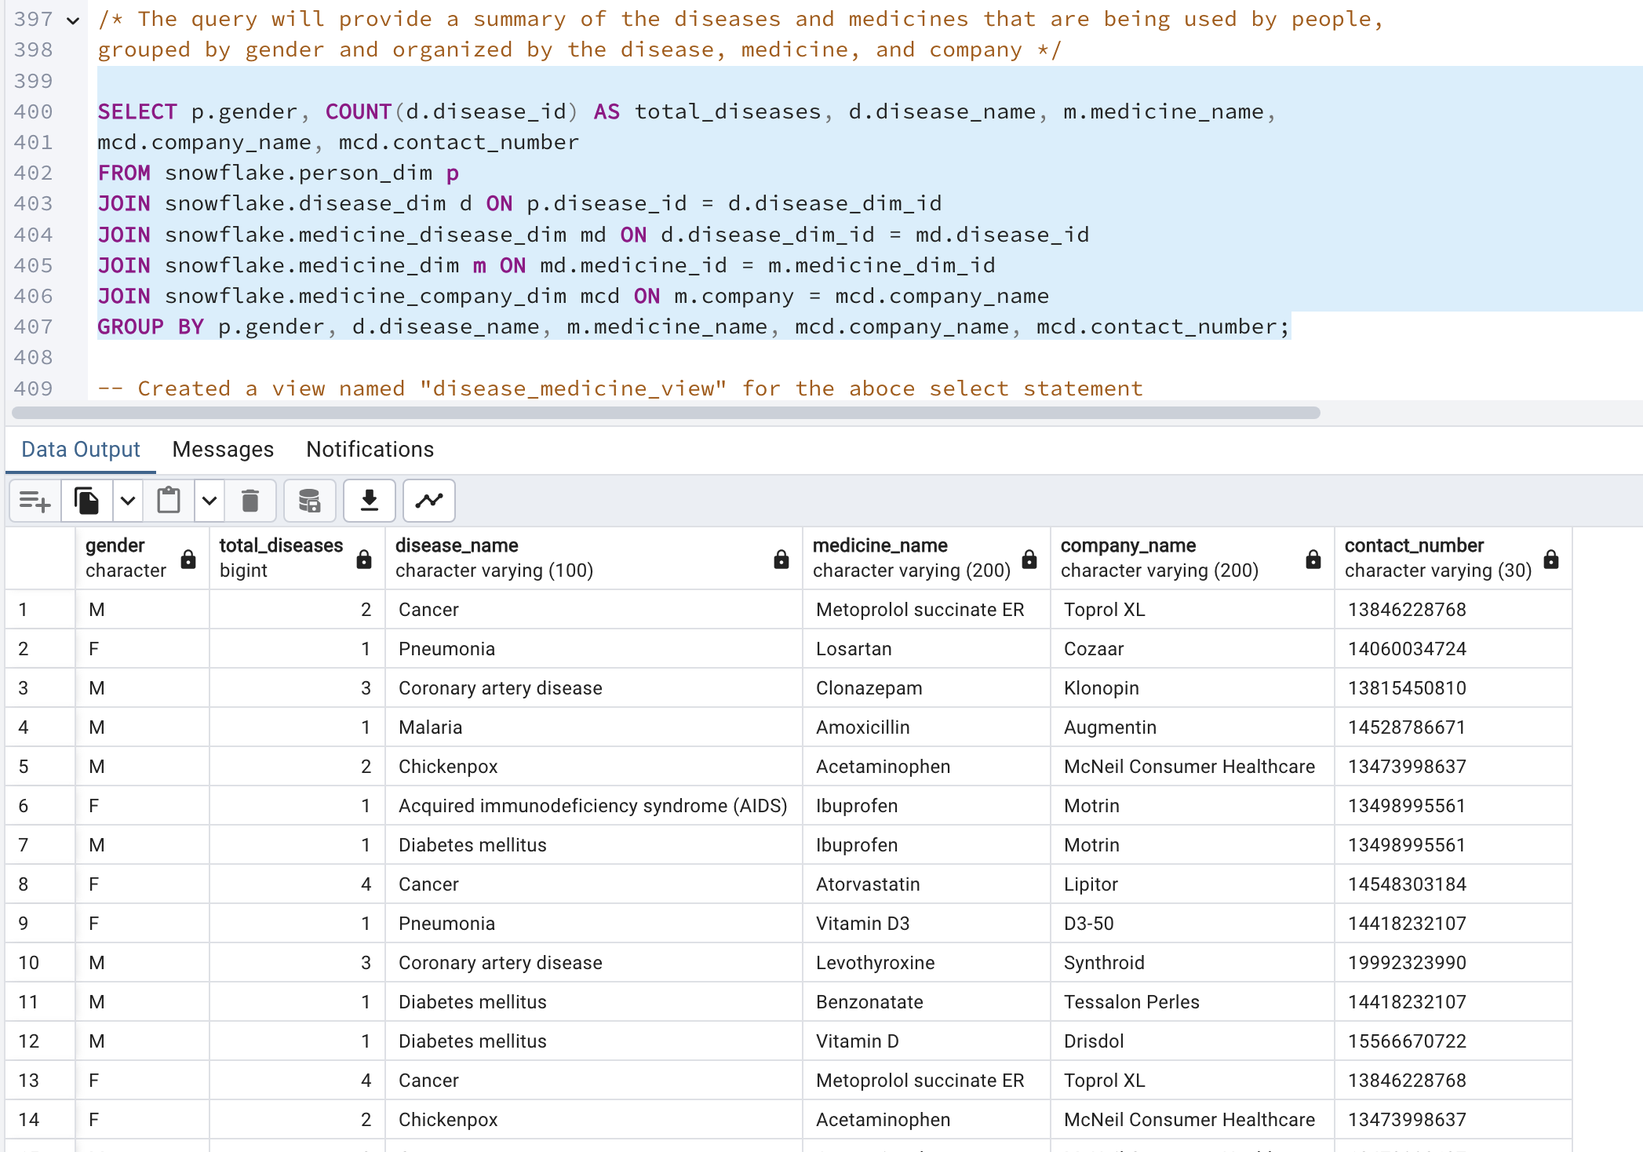**

7. Created a view named "disease\_medicine\_view" for the above select statement

**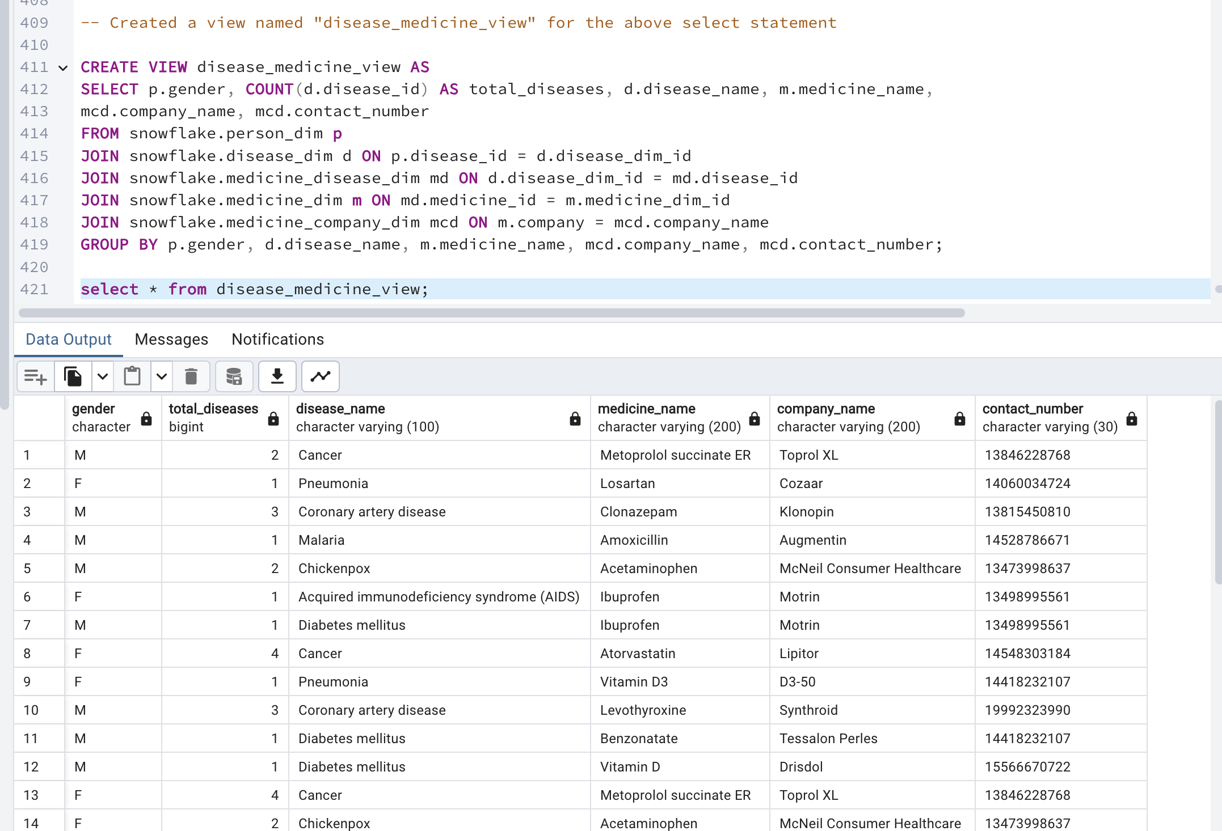**

**NoSQL Database(MongoDB)**

**Relational Databases (SQL)**

Relational databases organize data into tables, which consist of rows and columns. They utilize Structured Query Language (SQL) for managing and querying data. The schema is fixed, meaning the structure of the data must be defined before any data can be stored. Relationships between tables are established through foreign keys, and joining tables is a common operation for querying across entities. Examples include MySQL, Oracle, PostgreSQL, and MS-SQL. These databases are well-suited for complex transactional applications where transaction integrity and data consistency are critical.

**Non-relational Databases (NoSQL)**

Non-relational databases, also known as NoSQL databases, store data in formats other than the tabular relations used in relational databases. These include document stores, key-value stores, wide-column stores, and graph databases. NoSQL databases offer flexibility with data models (schema-free or schema-on-read), making them suitable for handling large volumes of diverse and unstructured data with ease. They excel in scalability, both vertically and horizontally, and are ideal for rapid development.

SQL database examples: [MySql](https://www.pluralsight.com/paths/mysql" \t "_blank), [Oracle](https://www.pluralsight.com/courses/oracle-database-12c-fundamentals), Sqlite, Postgres and MS-SQL. SQL databases are the best fit for heavy-duty transactional-type applications.

Features of non-relational databases

* They have the ability to store large amounts of data with little structure.
* They provide scalability and flexibility to meet changing business requirements.
* They provide schema-free or schema-on-read options.
* They have the ability to capture all types of data “Big Data” including unstructured data.
* They are document-oriented.

## MongoDB vs PostgreSQL

## The real question isn’t MongoDB vs PostgreSQL, but rather the best document database vs the best relational database. The data is stored in different structures by MongoDB and PostgreSQL. According to our most recent reports, the majority of complex applications in the market use many types of databases.

## PostgreSQL is preferred in scenarios where you need a high level of security, and anticipate scale in terms of transactions or queries. MongoDB is used for unstructured data storage. NoSQL databases are relatively new and are not preferred for highly secure applications.

**How the structure of Disease Model database would be different in a specific NO SQL**

In a NoSQL database like MongoDB, the structure of the Disease Model PostgreSQL database would be quite different. In MongoDB, data is stored in collections rather than tables, and each document in a collection can have a different structure. Therefore, you would not have the same table structure as in the relational database.

One way to structure the Disease Model database in MongoDB would be to create a separate collection for each entity, such as a "disease\_type" collection, a "disease" collection, a "location" collection, etc. Each document in these collections would represent a single record in the corresponding table in the relational database.

For example, the "disease\_type" collection might contain documents with the following structure:

{ "code": "D01", "description": "Cancer" }

{ "code": "D02", "description": "Diabetes" }

The "disease" collection might contain documents with the following structure:

{ "\_id": 1, "name": "Breast Cancer", "intensity\_level": 3, "type\_code": "D01" }

{ "\_id": 2, "name": "Type 2 Diabetes", "intensity\_level": 2, "type\_code": "D02" }

In this case, the "disease" collection has a "type\_code" field that stores the disease type code of the disease, which is a reference to a document in the "disease\_type" collection.

Here is an example of how the rest of the entities from the Disease Model PostgreSQL database might be structured in MongoDB:

Location: This collection might contain documents with the following structure:

{ "\_id": 1, "city\_name": "New York", "state\_province\_name": "New York", "country\_name": "United States", "developing\_flag": "N", "wealth\_rank\_number": 1 }

{ "\_id": 2, "city\_name": "Delhi", "state\_province\_name": "Delhi", "country\_name": "India", "developing\_flag": "Y", "wealth\_rank\_number": 136 }

Race: This collection might contain documents with the following structure:

{ "code": "R01", "description": "Asian" }

{ "code": "R02", "description": "African American" }

Person: This collection might contain documents with the following structure:

{ "\_id": 1, "last\_name": "Smith", "first\_name": "John", "gender": "M", "date\_of\_birth": "1990-01-01", "primary\_location\_id": 1, "race\_cd": "R01", "insurance\_id": 1 }

{ "\_id": 2, "last\_name": "Doe", "first\_name": "Jane", "gender": "F", "date\_of\_birth": "1995-05-05", "primary\_location\_id": 2, "race\_cd": "R02", "insurance\_id": 2 }

Diseased\_Patient: This collection might contain documents with the following structure:

{ "person\_id": 1, "disease\_id": 1, "severity\_value": 2, "start\_date": "2020-01-01", "end\_date": "2020-06-01" }

{ "person\_id": 2, "disease\_id": 2, "severity\_value": 3, "start\_date": "2021-02-01", "end\_date": null }

Race\_Disease\_Propensity: This collection might contain documents with the following structure:

{ "race\_code": "R01", "disease\_id": 1, "propensity\_value": 75 }

{ "race\_code": "R02", "disease\_id": 2, "propensity\_value": 50 }

Medicine: This collection might contain documents with the following structure:

{ "\_id": 1, "standard\_industry\_num": "1234567890", "name": "Aspirin", "company": "Bayer", "active\_ingredient\_name": "Acetylsalicylic Acid" }

{ "\_id": 2, "standard\_industry\_num

In a NoSQL database like Neo4j, the structure of the database would be even more different. Neo4j is a graph database, which means that data is stored in nodes and relationships rather than tables and rows. To structure the Disease Model PostgreSQL database in Neo4j, you would create nodes for each entity, such as a "Disease Type" node, a "Disease" node, a "Location" node, etc. Each node would have properties that store the attributes of the corresponding record in the relational database.

For example, a "Disease Type" node might have the following properties:

* code: "D01"
* description: "Cancer"

A "Disease" node might have the following properties:

* id: 1
* name: "Breast Cancer"
* intensity\_level: 3

To represent the relationships between these nodes, you would create edges that connect the nodes. For example, you might create a "HAS\_TYPE" edge that connects a "Disease" node to a "Disease Type" node, indicating that the disease has a certain type.

Overall, the structure of the Disease Model PostgreSQL database in a NoSQL database like MongoDB or Neo4j would be quite different from the structure in a relational database like PostgreSQL, as these databases have different ways of storing and organizing data.

MongoDB uses MongoDB Query Language (MQL) to retrieve data from the database. It’s easy to use and works in a way that’s similar to SQL with CRUD operations for creating, reading, updating, and deleting documents. Function names follow the syntax:

        <database>.<collection\_name>. <operation>.

The following are three examples that demonstrate this in practice:

INSERT: Create or insert a new document into a collection. If the collection does not exist, a new collection will be created.

        db.collection.insertOne() inserts one document into a collection.

        db.collection.insertMany() inserts multiple documents into a collection at once.

Here’s what inserting one document into the customer collection looks like:

        db.customer.insertOne (

        {

        firstname: “Jane”,

        lastname: “Mason”

        Address: “232 Petunia Drive, Atlanta, GA, 30311”

        }

FIND: This queries a collection of documents. Query filters and criteria can be applied to find specific documents.

        db.collection.find()

The following code finds all the documents in the customer collection:

        db.customer.find()

UPDATE: This modifies existing documents in a collection.

        db.collection.updateOne()

        db.collection.updateMany()

        db.collection.replaceOne()

Here’s how you’d update one document in the customer collection:

        db.customer.updateOne(

        { firstname: “Jane” },

                       { $set: { “address”, “5 Lavender Ave, Atlanta, GA, 30311”}

                        }

        )

**Architecture and Process**

**Overview of Our Application's Architecture**

**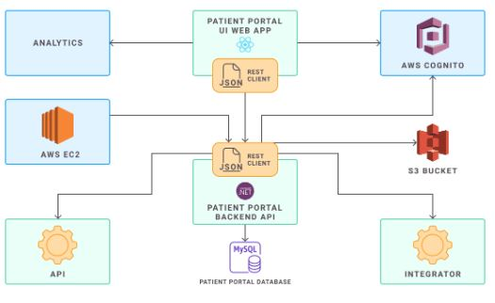**

Our application uses a mix of services from Amazon Web Services (AWS), which helps us adapt to different needs and scale efficiently. Here’s a simple breakdown of how everything works together:

**How We Handle Computing and Processing:**

* **AWS EC2**: We start with Amazon EC2 instances that act like our own personal computers in the cloud. This is where we host our servers. Managing these requires a bit of hands-on work, especially around security and scaling up when more people use our app.
* **AWS Lambda**: Alternatively, we also use AWS Lambda for some tasks. Lambda is pretty cool because it lets us run code without worrying about the servers at all. It automatically manages the computing resources we need. This is especially useful for tasks that need to adjust quickly to changing demands without any manual interference.

This application uses Amazon Web Services (AWS) EC2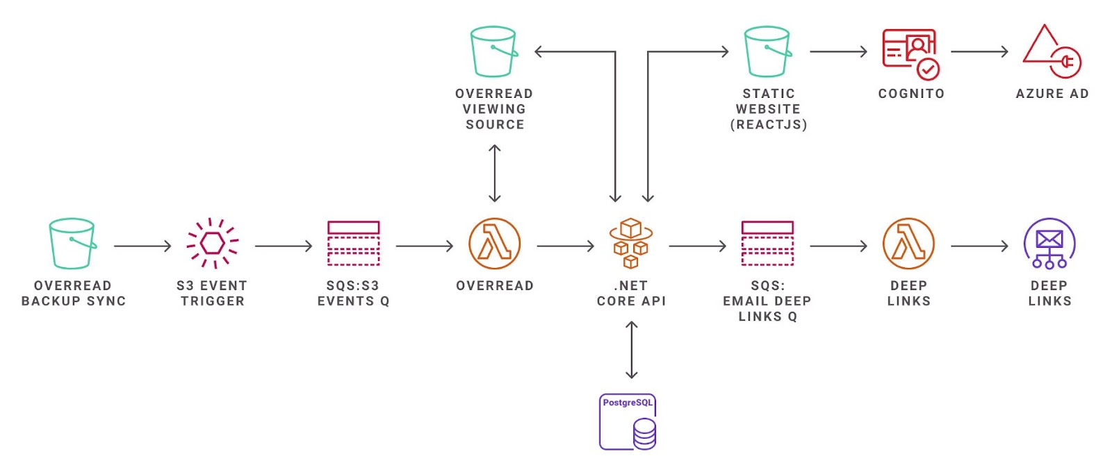

We can see serverless architecture used for reading and processing of data utilizing Lambda functions.  
  
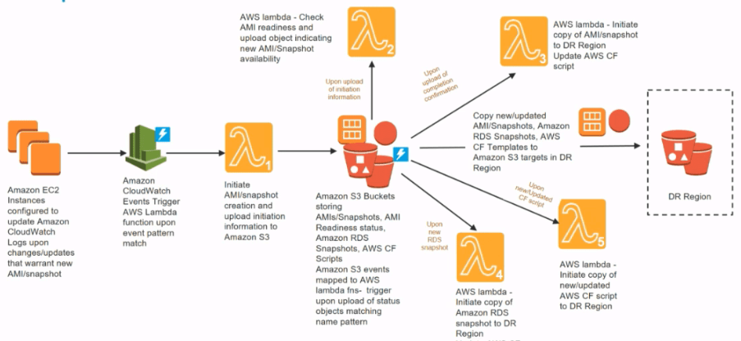

There are various approaches to building a DR plan using AWS Lambda. It is frequently advised to perform a backup and restore when making changes to the primary data centre configuration, such as updating code, jar files, or database tables. When creating EC2 instances, lambdas may be used to automate processes like EBS snapshot and AMI generation to back up your resources to S3. Since you would have a primary and a secondary data centre in every disaster recovery scenario, you should have a Lambda function that, once the new code is available in S3, replicates it to the secondary data centre, calls the CloudFormation scripts to create the AMI, and then deploys it on the secondary data centre.  
  
Serverless can never replace the whole stack when dealing with larger enterprises – it just isn’t reasonable, but it can bring a whole lot of value when combining Lambdas and other serverless services with the infrastructure in the right way.   
  
Getting Started with Serverless  
  
Achieving and maintaining compliance in the cloud benefits  
1. Improving Scalability and Speed of Delivery  
2. Ensuring Compliance  
3. Optimizing Costs

**Managing Users and Keeping Things Secure:**

* **AWS Cognito**: For managing user logins and keeping their information secure, we use AWS Cognito. It integrates well with other AWS services, ensuring that user data is handled safely and efficiently.

**Storing and Managing Data:**

* **AWS Aurora Serverless**: This is where our data lives. We use Aurora Serverless because it’s very flexible—it automatically adjusts its capacity based on how much it's being used, so we don’t overpay for resources we don’t need. Unlike traditional database setups where you might have to manually make changes as demand grows, Aurora Serverless speeds up or slows down automatically.

**Keeping Our Data Safe:**

* **Backup and Restore**: It's crucial to keep data safe. We regularly back up our data and can restore it if needed, especially when we update significant parts of our system like the database structures or the codebase itself.
* **Using Lambda for Disaster Recovery**: In case something goes wrong, AWS Lambda helps us automate the creation of backups and storing them safely in AWS S3. This ensures that both our main and backup systems are up-to-date and can be quickly restored to keep the service running smoothly.

**Starting with Serverless:**

* **Benefits of Going Serverless**: By using serverless architectures, we can scale our services more efficiently, comply with regulations more easily, and optimize costs—since we only pay for what we use. It also speeds up how quickly we can make changes and improvements to our service.

**Solving Common Problems:**

* **Handling Timeouts**: If our functions that connect to the database are having trouble due to timeouts, we check if everything is set up correctly (like security settings), use AWS RDS Proxy to manage the load, and adjust our functions to handle database connections better.

**Combining Old and New:**

* While serverless is great, it’s not always the answer for every single problem, especially in large, complex environments. However, it brings a lot of value when used in conjunction with traditional computing resources like EC2. This combination helps us balance flexibility with power, ensuring our application remains robust and responsive.

**In Conclusion**

By leveraging AWS’s diverse capabilities, our application is not only efficient but also robust and ready to handle whatever comes its way. Whether it’s managing how many resources to use or keeping user data secure, AWS helps us stay flexible and responsive to our users' needs.

**A small commentary on how advantages of Snowflake could help with your application.**

Snowflake is a cloud-based data warehousing solution that offers several benefits that can significantly enhance your application's data handling capabilities:

1. **Scalability:** With Snowflake, you won't have to worry about hitting storage limits or lacking processing power. It's designed to grow smoothly alongside your data needs. You can scale resources up or down depending on demand, ensuring you only pay for what you actually use. This flexibility is great for managing costs while accommodating growth or unexpected spikes in data usage.
2. **Performance:** Snowflake stands out for its speedy data processing. Thanks to its columnar storage and sophisticated optimization algorithms, your queries will run swiftly and smoothly. Plus, it automatically fine-tunes its performance, so your queries always run at their best without any extra effort from you.
3. **Security:** Keeping your data safe is a top priority, and Snowflake doesn’t take that lightly. It offers robust security features, including thorough data encryption, options for network isolation, and data masking. These features help protect your data from unauthorized access and ensure your information stays secure.
4. **Integration:** No matter the tools or platforms you’re already using, Snowflake plays well with others. It integrates seamlessly with a broad range of applications and analytics tools, which makes it easier to connect all parts of your data ecosystem without hassle.
5. **Ease of Use:** Snowflake is user-friendly, even for those who aren't tech experts. It uses a SQL-based query language, which is familiar to many and easy to learn for newcomers. This makes it simple to start extracting valuable insights from your data right away.

In summary, Snowflake is more than just a tool for storing large amounts of data. It’s a versatile platform that enhances how you handle data across your application from improving query speed and simplifying integrations to ensuring robust security and easy scalability.

Top of Form

Bottom of Form